County and Regional Secretary Guide to the Members’ Portal  
A handy guide on getting started

# 

UPDATED MARCH 2019

WWW.ARCHERYGB.ORG

## Guide to the online system for County and Regional Secretaries

To improve our services to our members, clubs, Counties and Regions, last year Archery GB invested in a new online membership system. This facilitates a quicker and improved membership process allowing Archery GB to offer additional support to our members and volunteers.

Archery GB has now phased out the use of paper membership forms and all the data is available online. County and Regional Secretaries have read-only access to the data on members in their area. This Guide is designed to support our County and Regional Secretaries/admin users in making the most of the online system.

## The advantages of using the online system rather than paper records are:

* Membership details are shown for each member which helps you calculate County/Regional fees due
* It is a quick way to check how many members are in clubs in your area
* Direct Members that have informed Archery GB they are members of the County/Region will show online, allowing cross referencing against County/Regional records
* Data becomes more reliable and real-time
* It is an effective way to contact the members in your area
* The whole process is significantly quicker
* It helps organisations comply with GDPR because it reduces the risk of personal details on paper forms being lost in the post
* County/Regional Secretaries could nominate up to two additional committee members to have access as admin users

## How do County/Regional Secretaries log in?

The login page is [www.archerygb.org/members-portal](http://www.archerygb.org/members-portal) Please login to your personal membership record, then choose to view the County/Region you have access to.If you are in your personal record, you can alsoswitch into your County/Regional record by selecting the name from the drop-down menu in the top right-hand corner:

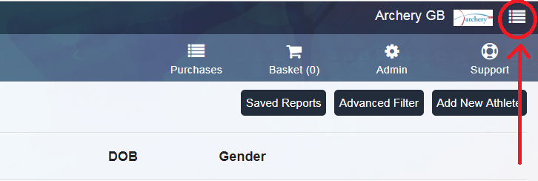

## Running a Report

Under the button **Saved Reports** near the top,there is a **County Membership Report** listing all members’ details in your area. This can be downloaded as an Excel spreadsheet. You can then order the report by club, or membership type, or any other way you wish.

## Creating bespoke reports

You can create bespoke reports allowing you to view how many members are in each of your clubs, or view members by membership type.

Select **Advanced Filter** then apply the fields you require. You can select the **Clubs** view (blue box on the left-hand side), or the **Athletes** box on the left-hand side, depending on what report you are trying to create.

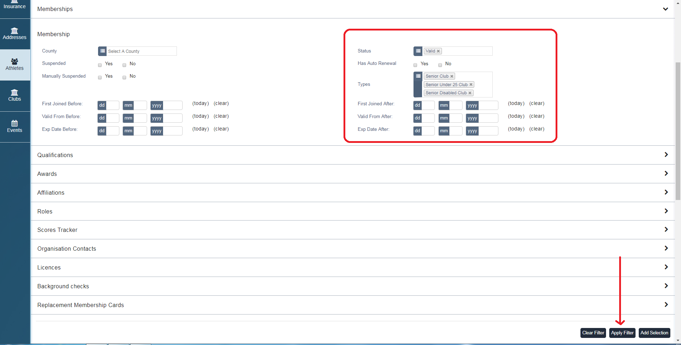

For example, on the **Athletes** view, you could go into the **Memberships** filter, then select the **Status** as **Valid**. Then you can add particular **types** like **Senior Club, Senior Under 25 Club, Senior Disabled** **Club** and then click **Apply Filter** button. This will create a list of only the Senior Club Members in your County. Click **Add Selection**, then **Download Report** and select the fields you wish to include on your list. Please contact Archery GB for more support should you need it.

## Direct Members

As you know, Archery GB Direct members are required to join the County and Region in which they live, unless through exceptional circumstances they have been approved to join a different nearby County. Archery GB advises members to join their County and Region before purchasing their Direct Membership, at which point they agree to and confirm the County/ Region they have joined:

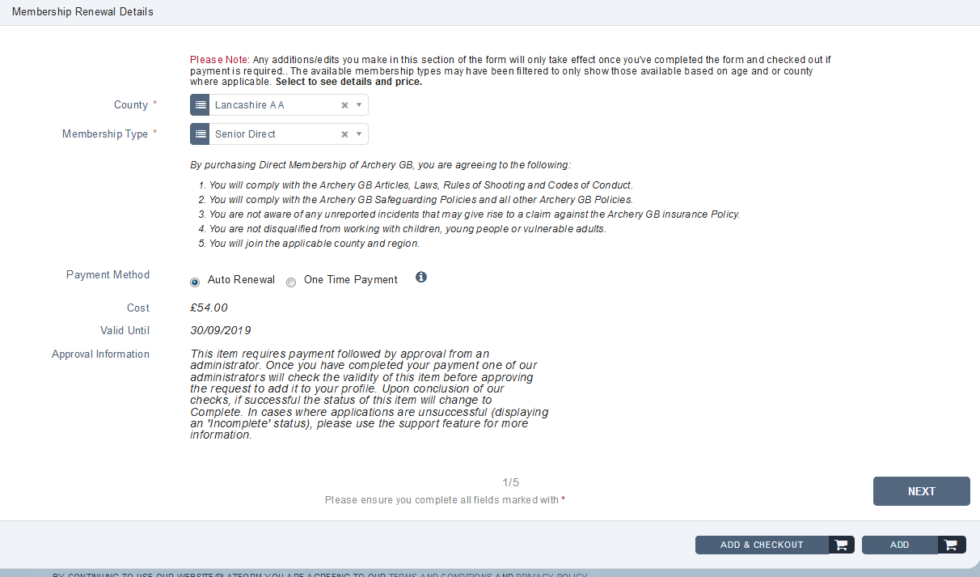

Archery GB encourages County and Regional representatives to ensure that all Direct Members within their area have paid the appropriate fees.

Since the introduction of the new online system, members receive both electronic membership cards (e-cards) and plastic membership cards. The e-cards show the membership type of the member, and their club or ‘Archery GB’ if they are a Direct Member. They do not show the County and Region, but the plastic cards do.

## Data Protection:

* Upon logging into the site (as a County or Regional Secretary/ admin user) you will be asked to agree to an Acceptable Use Policy, in addition to the usual acceptance of our Privacy notices. This is information around the access and use of the data in the platform, including the access, storage and distribution of information in the platform that you can use.  If you decline AUP and/or the privacy notice you will lose access to the Region or County site, and you will need to contact the GDPR team at Archery GB to resolve the issue.
* Our Privacy Notice covers the collection of the data, and the fact we share the data with the Counties and Regions for your use as required to manage your membership, however you should also have your own notice containing information on how/why you collect, store and process people’s information (also including anything we may not do for you). If the Privacy Notice, or Acceptable Use Policy gets updated at any time you will be notified upon logging into the platform and you will need to read and re-accept the applicable policy.
* If you are using the data for doing email communications to clubs, please ensure you filter for only currently active clubs (for clubs this is no expiry dates, or dates ending in 30/09/2019), and that you have the appropriate consent, and unsubscribe processes in place in your privacy notices and other documentation.
* We would expect that data is held securely (i.e. only in the system, or in a protected sheet / encrypted location) as required, and also that you are not passing on the data to any third party in general and also specifically not for any marketing / sales purposes. Should you have any Data Protection queries please write to [GDPR@archerygb.org](mailto:GDPR@archerygb.org) and we will do our best to assist you with an answer.



Archery GB

Lilleshall National Sports & Conferencing Centre  
Newport

Shropshire

TF10 9AT

**General Enquiries:**

Tel: 01952 677 888

Email: enquiries@archerygb.org

www.archerygb.org

Archery GB

@archerygb

Archery GB is the trading name of the Grand National Archery Society, a company limited by guarantee no. 1342150 Registered in England.