Target rounds including those for Visually Impaired (VI) archers

Introduction

This target rounds guide is taken from the latest edition of Archery GB's Rules of Shooting, approved in October 2016. If you need any more information you can find it on the Archery GB website at Support > Operations > Rules of Shooting. The rule covering outdoor rounds is 308 and for indoor rounds it is 405. For Burntwoods and WA VI rounds it is 1205 (outdoor and indoor). There are also helpful accompanying tables showing age groups for juniors.

Archery GB Metric Target Rounds – Outdoor (10 Zone Scoring)

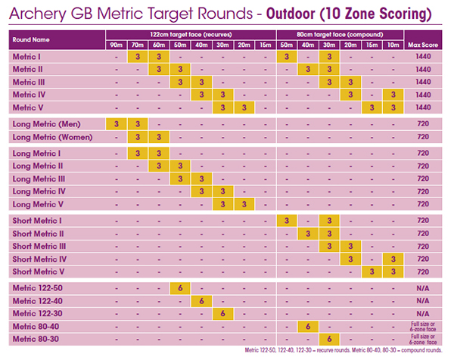

Record status competitions

For Record Status Competition purposes the Metric 80-40 and 80-30 are for compound bows only; the Metric 122-50, Metric 122-40 and Metric 122-30 are for non-compound bows only.

12 dozen rounds: Maximum score 1440

Number of arrows at each distance

Three dozen.

Face sizes

122cm for first two distances.
80 cm for second two distances.

Distances

All distances are in meters.

Metric 1

Distances: 70, 60, 50, 30.

Metric 2

Distances: 60, 50, 40, 30.

Metric 3

Distances: 50, 40, 30, 20.

Metric 4

Distances: 40, 30, 20, 10.

Metric 5

Distances: 30, 20, 15, 10.

6 dozen rounds: Maximum score 720

Number of arrows at each distance

Three dozen.

Face sizes

Long Metrics: 122cm.
Short Metrics: 80 cm.

Distances

All distances are in meters.

Long Metric (Men)

Distances: 90, 70.

Long Metric (Women)

Distances: 70, 60.

Long Metric 1

Distances: 70, 60.

Long Metric 2

Distances: 60, 50.

Long Metric 3

Distances: 50, 40.

Long Metric 4

Distances: 40, 30.

Long Metric 5

Distances: 30, 20.

Short Metric 1

Distances: 50, 30.

Short Metric 2

Distances: 40, 30.

Short Metric 3

Distances: 30, 20.

Short Metric 4

Distances: 20, 10.

Short Metric 5

Distances: 15, 10.

6 dozen rounds: Single distance

Face sizes

122 rounds: 122cm.
80 rounds: 80 cm.

Distances

All distances are in meters.

Metric 122-50

Distance: 50

Metric 122-40

Distance: 40

Metric 122-30

Distance: 30

Metric 80-40

Distance: 40

Metric 80-30

Distance: 30

World Archery Target Rounds – Outdoor (10 Zone scoring)

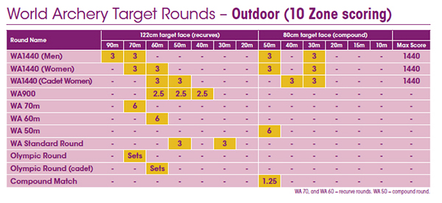

Record status competitions

For Record Status Competition purposes the WA 50m is for compound bows only; the WA 70m and WA 60m are for non-compound bows only.

12 dozen rounds: Maximum score 1440

Number of arrows at each distance

Three dozen.

Face sizes

122cm for first two distances.
80 cm for second two distances.

Distances

All distances are in meters.

WA 1440 (Men)

Distances: 90, 70, 50, 30.

WA 1440 (Women)

Distances: 70, 60, 50, 30.

WA 1440 (Cadet Women)

Distances: 60, 50, 40, 30.

7.5 dozen round

Number of arrows at each distance

2.5 dozen.

Face size

122cm for all distances.

Distances

All distances are in meters.

WA 900

Distances: 60, 50, 40.

6 dozen rounds: Single distance

Face sizes

70m and 60m: 122cm.
50m: 80 cm.

Distances

All distances are in meters.

WA 70m

Distance: 70

WA 60m

Distance: 60

WA 50m

Distance: 50

6 dozen round: Two distances

Number of arrows at each distance

Three dozen.

Face sizes

122cm for all distances.

Distances

All distances are in meters.

WA Standard Round

Distances: 90, 70.

Olympic and Match rounds: Single distances

Number of arrows at each distance

70m and 60m: sets.
50m: 1.25 dozen.

Face sizes

70m and 60m: 122cm.
50m: 80 cm.

Distances

All distances are in meters.

Olympic Round

Distance: 70

Olympic Round (Cadet)

Distance: 60

Compound Match

Distance: 50

World Archery VI Target Rounds – Outdoor (10 Zone scoring. All: 30m.)

WA VI Outdoor (1440)

See Rule 1205(b).

60 cm face: 3 dozen.
80 cm face: 3 + 3 dozen.
122 cm face: 3 dozen.

WA 30m

See Rule 1205(b).

80 cm face: 6 dozen.

WA VI Olympic

80 cm face: sets.

Archery GB Imperial Outdoor Rounds (Five zone scoring – 9, 7, 5, 3, 1. 122cm face)

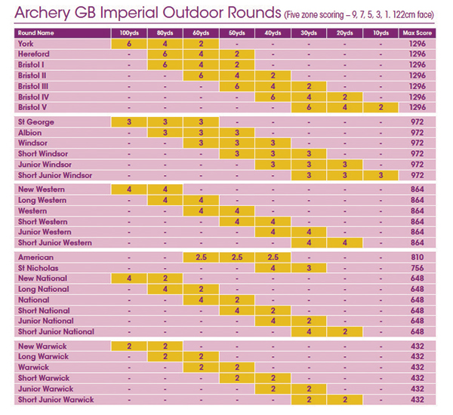

12 dozen rounds: Maximum score 1296

Number of arrows at each distance

First: 6 dozen.
Second: 4 dozen.
Third: 2 dozen.

Distances

All distances are in yards.

York

Distances: 100, 80, 60.

Hereford

Distances: 80, 60, 50.

Bristol 1

Distances: 80, 60, 50.

Bristol 2

Distances: 60, 50, 40.

Bristol 3

Distances: 50, 40, 30.

Bristol 4

Distances: 40, 30, 20.

Bristol 5

Distances: 30, 20, 10.

9 dozen rounds: Maximum score 972

Number of arrows at each distance

Three dozen.

Distances

All distances are in yards.

St George

Distances: 100, 80, 60.

Albion

Distances: 80, 60, 50.

Windsor

Distances: 60, 50, 40.

Short Windsor

Distances: 50, 40, 30.

Junior Windsor

Distances: 40, 30, 20.

Short Junior Windsor

Distances: 30, 20, 10.

8 dozen rounds: Maximum score 864

Number of arrows at each distance

Four dozen.

Distances

All distances are in yards.

New Western

Distances: 100, 80.

Long Western

Distances: 80, 60.

Western

Distances: 60, 50.

Short Western

Distances: 50, 40.

Junior Western

Distances: 40, 30.

Short Junior Western

Distances: 30, 20.

7.5 dozen round: Maximum score 810

Number of arrows at each distance

2.5 dozen.

Distances

All distances are in yards.

American

Distances: 60, 50, 40.

7 dozen round: Maximum score 756

Number of arrows at each distance

First: 4 dozen.
Second: 3 dozen.

Distances

All distances are in yards.

St Nicholas

Distances: 40, 30.

6 dozen rounds: Maximum score 648

Number of arrows at each distance

First: 4 dozen.
Second: 2 dozen.

Distances

All distances are in yards.

New National

Distances: 100, 80.

Long National

Distances: 80, 60.

National

Distances: 60, 50.

Short National

Distances: 50, 40.

Junior National

Distances: 40, 30.

Short Junior National

Distances: 30, 20.

4 dozen rounds: Maximum score 432

Number of arrows at each distance

Two dozen.

Distances

All distances are in yards.

New Warwick

Distances: 100, 80.

Long Warwick

Distances: 80, 60.

Warwick

Distances: 60, 50.

Short Warwick

Distances: 50, 40.

Junior Warwick

Distances: 40, 30.

Short Junior Warwick

Distances: 30, 20.

Archery GB Burntwood Outdoor Rounds (Five zone scoring – 9, 7, 5, 3, 1. Adults: 30m. Juniors: 15m.)

Burntwood – York round

40 cm face: 6 dozen.
60 cm face: 4 dozen.
80 cm face: 2 dozen.

Burntwood – Hereford/All Bristol rounds

60 cm face: 6 dozen.
80 cm face: 4 dozen.
122 cm face: 2 dozen.

Burntwood – St George round

40 cm face: 3 dozen.
60 cm face: 3 dozen.
80 cm face: 3 dozen.

Burntwood – Albion/Windsor rounds

60 cm face: 3 dozen.
80 cm face: 3 dozen.
122 cm face: 3 dozen.

Burntwood – All Western rounds

60 cm face: 4 dozen.
80 cm face: 4 dozen.

Burntwood – All National rounds

60 cm face: 4 dozen.
80 cm face: 2 dozen.

Burntwood – All Warwick rounds

60 cm face: 2 dozen.
80 cm face: 2 dozen.

Burntwood – American round

60 cm face: 2.5 dozen.
80 cm face: 2.5 dozen.
122 cm face: 2.5 dozen.

Burntwood – St. Nicholas round

80 cm face: 4 dozen.
122 cm face: 3 dozen.

Indoor Rounds – Archery GB

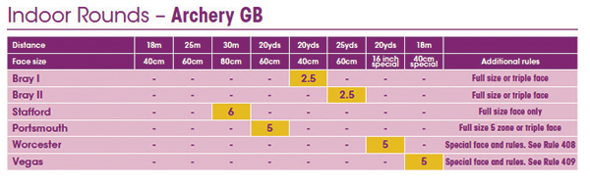

Bray 1

2.5 dozen arrows at 20 yards on a 40cm face. Can use full size or triple faces.

Bray 2

2.5 dozen arrows at 25 yards on a 60cm face. Can use full size or triple faces.

Stafford

6 dozen arrows at 30 meters on an 80cm face. Can use full size or triple faces.

Portsmouth

5 dozen arrows at 20 yards on a 60cm face. Full size, 5 zone or triple faces.

Worcester

5 dozen arrows at 20 yards on a 16 inch special face. Special face and rules. See Rule 408.

Vegas

5 dozen arrows at 18 meters on a 40 cm special face. Special face and rules. See Rule 409.

Indoor Rounds – World Archery

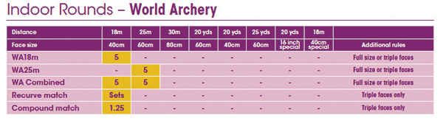

WA 18m

5 dozen arrows at 18 meters on a 40cm face. Can use full size or triple faces.

WA 25m

5 dozen arrows at 25 meters on a 60cm face. Can use full size or triple faces.

WA Combined

5 dozen arrows at 18 meters on a 40cm face and 5 dozen arrows at 25 meters on a 60cm face. Can use full size or triple faces.

Recurve match

Sets of arrows at 18 meters on a 40cm face. Triple faces only.

Compound match

1.25 dozen arrows at 18 meters on a 40cm face. Triple faces only.

World Archery VI Indoor Rounds (All: 18m.)

WA VI Indoor

See Rule 1205(b).

60 cm face: 5 dozen.

WA VI Indoor match

60 cm face: sets.

