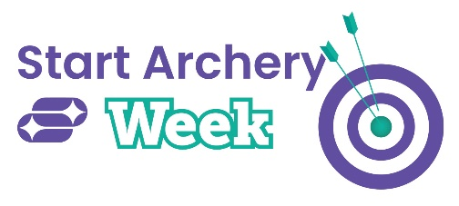

DRAW BACK YOUR BOWS FOR START ARCHERY WEEK
[insert name of club] is welcoming everyone to have a go at archery
Xx April 2024 - Now in its 12th year, Start Archery Week (4-12 May) sees archery clubs and providers across the country open their doors to potential archers, giving people of all ages and abilities the chance to try archery for the first time.
One of the most accessible sports around, it’s fun and inclusive and perfect for anyone wanting to try something new, either on their own or with family and friends. Whether you’ve tried archery before or have never thought about picking up a bow and arrow, this is a perfect chance to give it a go. It’s also the ideal opportunity to discover the joy of this inclusive sport ahead of the Paris 2024 Olympic and Paralympic Games.
[Insert name of provider] is inviting adults and children alike to take part throughout Start Archery Week. On [insert dates], [insert name] will be hosting its very own event, inviting locals from across [insert town or region] to come and give archery a shot. The event will take place at [insert times] at [insert location] and is open to [all ages/anyone aged xx and above]. [Please insert any additional details here including any charges and if slots need to be booked].
Participants will not only be able to have a go at the sport and meet friendly members of the club, they will also be able to spend time with the coaches who will guide them through the basics ensuring a safe and enjoyable introduction to the sport. In addition, visitors will be able to sign up for a beginner’s course to kickstart their archery journey (delete if not applicable).
[insert name], based in [insert address or town], has been running for [insert number] of years and has members of all abilities, who take part in archery each week.
"Aside from its brilliant social appeal, archery has many health benefits for both body and mind and it’s for everyone, regardless of physical ability," comments [insert name /job title/committee role]. "This year’s nationwide event is shining a light on the mental health benefits of archery and how the sport can help people’s minds as well as their bodies. It can support increased mindfulness, enhance mental and emotional wellbeing, reduce stress and boost confidence as well as developing strength and fitness. Everyone at [insert name of provider] is really looking forward to welcoming participants to our event so please do come down if you can.”
To find out more about their Start Archery Week events visit [insert website] or contact [insert name/number]. All equipment will be provided on the day, please feel free to [insert method of finding out more/ book here] for further details.
For more information about Start Archery Week and how to get involved, please visit www.startarchery.co.uk
-ends-

