GB ARCHERS PUT ON A TRIUMPHANT DISPLAY ON HOME SOIL AT THE NATIONAL TOUR FINALS
- Ella Gibson continues her successful run and takes gold in the Compound Women
- Patrick Huston, Penny Healey and Adam Carpenter hit gold
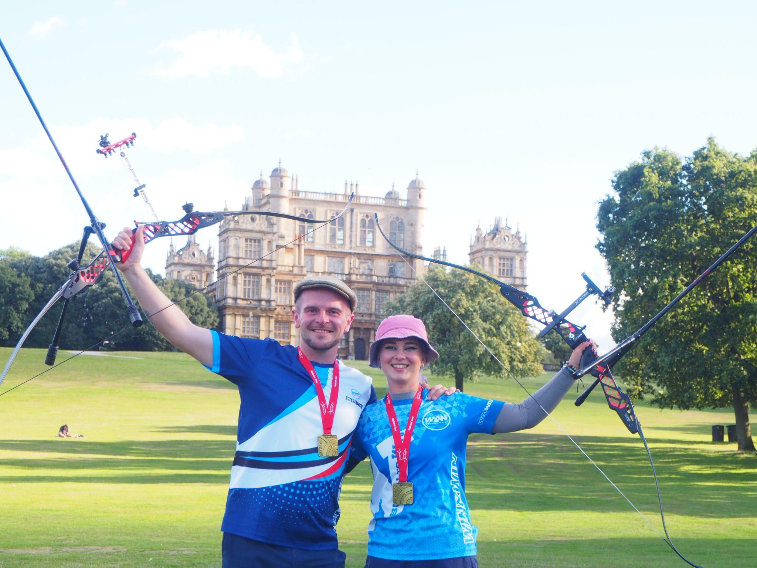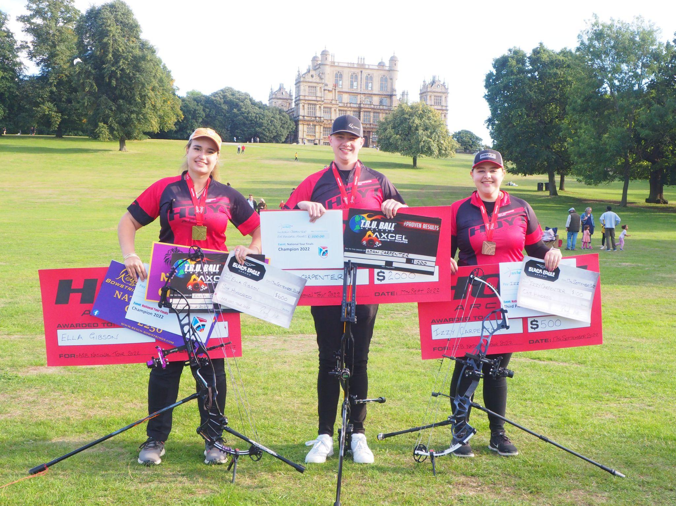
(Image credits: Left - Patrick Huston and Penny Healey; Right - Ella Gibson, Adam Carpenter and Izzy Carpenter. Credit Archery GB)
20 September 2022: On the 16th and 17th September, the UK’s finest archers assembled at Wollaton Hall in Nottingham for the National Tour Finals, competing for top podium spots in the disciplines of Recurve, Compound and Barebow archery.
World number one Ella Gibson continued her recent run of success triumphing at the National Tour Finals to secure gold in the Compound Women competition. Ella is due to compete in the 2022 Hyundai Archery World Cup Final in Mexico in October. Layla Annison, who won the National Tour Finals in 2021, secured silver, whilst Izzy Carpenter, who became European Champion in Munich in mid June, finished third in bronze medal position.
Olympic archer Patrick Huston shot to victory winning gold in the Recurve Men event, taking him to five National Tour final wins, with two in a row this year and last year. Steve Davies picked up the silver medal and Sum Hin Moses Cheung took bronze.
17-year-old Penny Healey secured gold in the Recurve Women event, making it back-to-back National Tour wins for her, to add to her World Cup Antalya 2022 team gold medal and her win in the indoor World Series final. Her fellow European teammate Louisa Piper, who won gold alongside Penny in the Recurve Under-21 Women’s Team in the European Youth Championships last month, took silver and British Olympian Sarah Bettles picked up bronze.
In the Compound Men competition, Adam Carpenter, brother of Izzy Carpenter, shot to gold, beating Kai Thomas-Prause and winning his third consecutive National Tour title. Thomas-Prause took silver medal position and Adam Ravenscroft bronze.
In the Barebow Men competition, Wilco van Kleef-Bolton saw off competition from Stafford Archers’ Ralph Barwise to win gold.
The Barebow Women events saw Helen Brown of Bowmen of Pendle and Samlesbury, beat Kim Doherty to take the top spot.
This was the sixth time the National Tour competition has been held at Wollaton.
-ends-
Notes to Editors

Image Credit: Archery GB

Hi-res images of each archer who won a medal are available from Dropbox link with credit Archery GB: https://www.dropbox.com/sh/2jravg3ynsuzmds/AABJE3pWIykLqJINSxLBZc-ua?dl=0

Further images of Friday’s competition, which should be credited to Archery GB, can be downloaded here.
Further images of Saturday’s competition, which should be credited to archery GB, can be downloaded here.

As a mark of respect to Her Majesty Queen Elizabeth II, both the European Para Archery Cup Finals and National Tour Finals were altered to allow those attending to pay tribute to the Queen.

All flags were flown at half-mast and GB athletes wore black armbands or ribbons as a mark of respect during this period of National Mourning. Both events also began with the National Anthem, followed by one minute’s silence.
Penny Healey: Penny is the youngest on the squad, at just 17 years old. She started archery when she was 9, after watching the Disney movie “Brave”. It inspired her to have a go at archery, as it looked enjoyable and she used to do horse riding. Penny did her beginners course at Audco Archers. Penny’s proudest achievement to date is winning the Indoor World Series Finals in 2022 in Las Vegas. Along with shooting the European junior, national senior and junior WA720 record. Her advice to archers is to work hard and enjoy what you do. “You shoot your best when you're having fun, and the hard work is what helps you reach your full potential as an archer.” Penny’s goals for this year were to make the senior international team, put in some new personal bests and to medal internationally. Outside of archery, she likes to listen to music, and achieved her grade 5 for violin.
Ella Gibson: Ella first tried archery in October, 2014, when some coaches from Xperience archery came to her secondary school. They put on a six-week taster session after school and that led to a beginners’ course with Deer Park Archers and she joined the club in June, 2015. Ella has competed internationally since 2018, winning a silver at the European Outdoor Championships last summer, bronze at the Lancaster Classic and team medals on the World stage. In February, 2022, her first big win individually on the international stage came when she took gold and the compound women European Indoor Champion title in Slovenia. Ella’s family own and run Dolcetti Ice Cream, in Cirencester. They are moving to bigger premises, which will have a 25-metre indoor range so that Ella can continue to shoot, whatever the weather.
Adam Carpenter: Adam is from Barnsley Archery Club and started archery when he went for a family holiday to Center Parcs. Adam, who was then seven, and his older sister Izzy loved it and took a beginners’ course. His biggest achievements so far are back-to-back National Tour Champion 2021 and 2020, along with setting the UK junior compound indoor 18m national record of 595. Adam’s goals for the year are to make the team for the senior & junior European championships, also to get the third in a row National tour win. He has just started a new job at Custom Built Archery. Outside of archery he enjoys drumming and spending time with his girlfriend, family and friends.
Izzy Carpenter: Izzy first started archery when she was ten years old, having tried the sport on a family holiday. Izzy placed 5th at the 2021 Yankton Senior World Championships with the Compound Women’s Team. Having completed a Master’s Degree in Creative writing in 2021, she not only competes internationally for Great Britain but is also a Match Reporter for Archery GB’s website and magazine. Izzy’s local club is Barnsley Archery Club in South Yorkshire. Izzy won individual gold at the European Championships in Munich this year, along with Compound Women’s Team gold with Ella Gibson and Jessica Stretton PLY.
Patrick Huston: Patrick, a 3x World Champion at junior level, competed in the Tokyo 2020 Games, his second Olympic Games. The highlight was fifth in the men’s team and eighth in the mixed team. He is originally from Belfast, Northern Ireland. Patrick won silver with mixed team partner Naomi Folkard at the European Games in 2019 and Bronze at the World Championships in 2017. Patrick has a collection of European Field Medals, Junior and senior with individual and team podiums. He was part of the bronze winning team at the Archery World Cup in Antalya, 2018. During the 2021 season, Patrick won silver individually at the European Field Championships in Croatia and set 4 separate national records along with a record setting 4th win of the AGB National Tour.
World Archery Bio - https://worldarchery.sport/profile/12648/patrick-huston/biography

Steve Davies: Steve grew up in Tonbridge, in Kent. His first club was Friars Gate Archers, in Sussex, however he currently shoots with Bowbrook Archers. Since moving up to Shropshire in April he has become a part of Bowbrook and he says they couldn’t be more welcoming! His biggest achievement is coming 3rd at the National tour Final in 2021. This year, Steve’s goal is to make sure he has fun while shooting and try to make it to the National Tour final. He has been shooting since he was 11. Starting with compound then in 2012 when seeing archery at the Olympics, he was inspired and changed to recurve. He has been on PAPP since October 2021. Outside of archery, Steve really like cars, racing to be more exact. He is a big fan of Formula 1 and has watched it every weekend for 10 years!
World Archery Bio - https://worldarchery.sport/profile/43360/stevie-kent/biography

Sarah Bettles: Sarah made her Olympic debut at the Tokyo 2020 Games, finishing 17th individually, ninth in the team and eighth in the mixed team. She won gold in the women’s recurve team event at the 2019 European Games, Minsk. She was part of the team that won bronze at the World Archery Championships in 2019, in Den Bosch, Netherlands. She has a Master’s in Biomedical Engineering from Cardiff University and has worked as an engineer before putting her career on hold to become a full-time athlete. She is originally from Essex but now lives in Telford, Shropshire. Sarah is a keen horserider in her spare time and also competed in trampolining before taking up archery.
World Archery Bio - https://worldarchery.sport/profile/18860/sarah-bettles/biography

Layla Annison: Layla Annison is from Wymondham Archers. She started archery at an after school club at her junior school. After leaving for high school, she got her first ever compound bow at the age of 11. She saw that the junior school have an archery club there, joined, and fell in love with the sport immediately. Joined Archery GB development squad at 13 then started representing GB at 14. Layla’s biggest achievement so far is win a silver medal at the Hyundai World Cup Stage in Paris of 2021 and winning the National Tour final in September 2021. Her goals for the year are to retain my space on GB both senior and youth. Shoot a 700 on a WA720. Maintain good health, mentally and physically. She is currently studying an Access course to HE (higher education) in science and currently applying to go to university to hopefully study physiotherapy. Outside of archery, Layla enjoys painting nails and going to the gym.
Kai Thomas-Prause: Kai Thomas-Prause shoots at High Weald Archery Club. He started shooting 12 years ago, aged 9, his dad, Gareth, shot when he was younger at school but stopped as life got too busy but wanted to pick it up again and so his dad, sister and Kai all went to their local club in Hastings (Bayeux Bowmen) for a beginner’s course. When he was younger, he never used to have good dexterity in his fingers and so the club coach started him off on compound with a wrist release, so he was able to shoot and he has never looked back. Kai’s biggest success is being selected for the British team (Junior/Senior) every year since 2017. He says it could be easy to take this for granted but it is his biggest achievement. Kai has enjoyed every minute of it and cannot wait to see how long he can keep at this level for. His biggest achievement at a competition is a bronze medal at Nimes, World Cup Stage 3 in 2020, that was nerve-wracking but an amazing experience and a huge learning curve in his psychological approach to shooting. Kai has just graduated with a BSc in Psychology from the University of Warwick. Kai’s biggest passion outside of archery is watching and playing football. He is a big Liverpool FC fan and trains with his local team most weeks (whilst trying not to get injured!). On top of all of this, Kai has also started to teach himself guitar (although it's going very slowly...).

Adam Ravenscroft: Foxes Archery Club member Adam Ravenscroft is from Leicester and first started shooting in 1995. He has since featured in 11 National Tour finals.

Ralph Barwise: Ralph Barwise has been shooting barebow for four years and is a member of Stafford archers.

Wilco van Kleef-Bolton: Originally from the Netherlands, Wilco van Kleef-Bolton is now based in Dagenham and shoots with the Noak Hill Archers. He has been shooting for 27 years, although had a break in the middle when his children came along.

Helen Brown: A member of the Bowmen of Pendle and Samlesbury, Helen Brown hails from Preston and has been shooting for seven years.

Kim Doherty: Kim Doherty hails from Preston, has been shooting for seven years and is a member of the Bowmen of Pendle and Samlesbury.

Sum Hin Moses Cheung: Worthing Archery Club member Sum Hin Moses Cheung, whose hometown is Hong Kong, has been shooting for seven years.

Media Contacts: White Tiger PR - Archery@whitetigerpr.com
Leanne Barton / Leanne.barton@whitetigerpr.com / 07568 925069
Kimberley Powles / kimberley.powles@whitetigerpr.com / 07966 867827

About Archery GB
Archery GB is the British body for all forms of archery in the UK, an inclusive sport which lends itself to all spectrums of the population - regardless of age, disability or gender. With over 820 clubs and over 34,400 members, Archery GB is affiliated to World Archery, British Olympic Association & British Paralympic Association. More information www.archerygb.org. Beginners can visit www.startarchery.co.uk to find beginners’ courses and clubs near them and to learn more about the sport.

