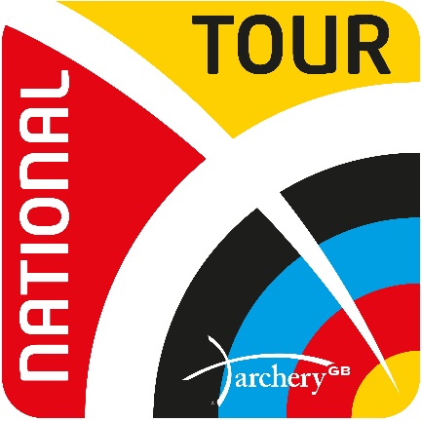
Archery GB National Series Hall of Fame
Grand Final Champions of National Series 2009 – 2016 National Tour 2017 – 2022
 |  | 2009  Lilleshall | ²⁰¹⁰  ^{Leamington} |  | 2011  Liverpool |  | 2012  Oxford |  | 2013  Nottingham |  | 2014  Nottingham | 2015  Nottingham | 2016  Nottingham | 2017  Birmingham | 2018 Lilleshall | 2019 Caldicot | 2020  Lilleshall | 2021 Lilleshall | 2022  Nottingham
RW |  | Charlotte Burgess | ^{Naomi Folkard} |  | Charlotte Burgess |  | Alison Williamson |  | Amy Oliver |  | Amy Oliver | Naomi Folkard | Nichola Turner | Naomi Folkard | Bryony Pitman | Jaspret Sagoo | Bryony Pitman | Penny Heely | Penny Heely
RM |  | Simon Terry | ^{Simon Terry} |  | Simon Terry |  | Larry Godfrey |  | Alan Wills |  | Larry Godfrey | Patrick Huston | Patrick Huston | Patrick Huston | Alex Wise | Tom Hall | Tom Hall | Patrick Huston | Patrick Huston
CW |  | Lucy O'Sullivan | ^{Nichola Simpson} |  | Lucy O'Sullivan |  | Christie Westman |  | Dani Brown |  | Naomi Jones | Nichola Simpson | Lucy Mason | Sarah Prieels | Jacquie Holmes | Ella Gibson | Bayley Sargeant | Layla Annison | Ella Gibson
CM |  | Duncan Busby | ^{Chris White} |  | Chris White |  | Adam Ravenscroft |  | Michael Cauwe |  | Adam Ravenscroft | Neil Bridgewater | Neil Bridgewater | Adam Ravenscroft | James Mason | James Mason | Adam Carpenter | Adam Carpenter | Adam Carpenter

