ARCHERY GB ACHIEVES OUTSTANDING SUCCESS AT EUROPEAN GRAND PRIX
- GB team win 3 Gold and 2 Silver Medals on home soil
- The best in Europe gathered to compete in Shropshire at the week-long event
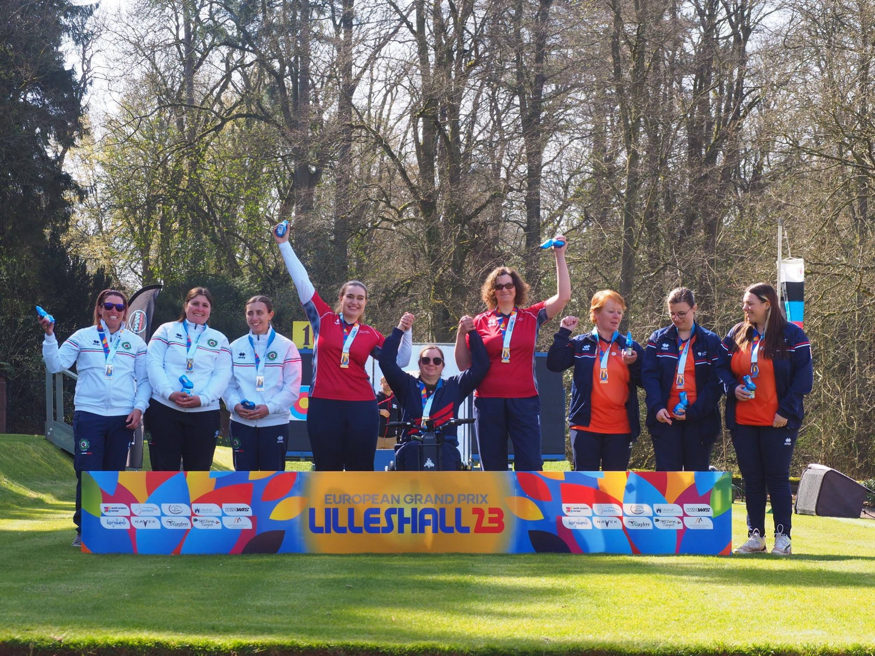
(Photo left to right: Taking their gold medal Compound Women’s Team: Ella Gibson, Jess Stretton and Lizzy Foster (Credit World Archery).
12 April 2023: The GB Archery team started their 2023 season with a bang and delighted a home crowd to successfully beat some of the best in Europe to win 3 gold, and 2 silver medals at the European Grand Prix event held in Lilleshall, Shropshire.
The final day of the week-long event showcased some fantastic finals which included the GB Compound Women’s Team of Ella Gibson, Jess Stretton, and Lizzy Foster skilfully securing their gold medal by winning a nail-biting final that finished 230-229.
An exciting showdown followed in the Compound Mixed Team gold medal match, with Kai Thomas-Prause and Ella Gibson representing GB against Luxembourg. Despite a valiant effort, GB narrowly missed out on the gold, losing 154-157 to the Luxembourg team. Nevertheless, Kai Thomas-Prause expressed his joy at getting to shoot in front of a home crowd, saying, “It’s really nice to shoot on the Orangery with the home crowd - everyone shouting our names and cheering us on. Obviously, we’re a bit disappointed not to get the gold but I'm happy.”
Ella Gibson continued her winning streak in the Compound Women's Finals, facing off against Mariya Shkolna from Luxembourg. After a draw in the first set, Ella pulled ahead in the subsequent sets, ultimately winning 145-143 and adding another gold medal to her achievements.
In the Recurve Mixed Team gold medal finals, Tom Hall and Penny Healey represented GB against the Netherlands. GB took an early lead with a brilliant opening set, but the Dutch team fought back, resulting in a draw after three sets. The tension was palpable, but despite a strong finish, GB had to settle for the silver medal, with the Netherlands taking gold.
Penny Healey, in her final match of the tournament, competed against Germany's Elina Idensen in the Recurve Women's Final. After a draw in the first set, Penny pulled ahead and secured a comfortable win with a final score of 7-1 in her favour. Penny was absolutely overjoyed to be named champion, she commented, “It feels amazing to do this in front of my family and especially on home turf, it has a special place in my heart now.”
The GB team’s success at the European Grand Prix has not only proven the team’s strength for the season ahead but, also successfully secured the Recurve Women’s Team a vital quota spot to join the GB Recurve Men’s Team at the European Games later this year where archers can gain Olympic quota places.
For more information on Archery GB and its performance teams, please visit archerygb.org
-Ends-
Notes to Editors:

The European Grand Prix is an annual tournament with over 300 of the best recurve and compound archers from all over Europe competing. It is also a qualifying tournament for the European Games which takes place in Krakow, Poland from 21 June to 2 July 2023 where athletes will have the opportunity to qualify for the 2024 Paris Olympics.

Athlete Profiles:

Tom Hall: Tom made his Olympic Debut at the Tokyo 2020 Games. He finished 33rd individually and fifth in the team. Tom has a PhD in Chemistry from the University of Warwick. He lives in Kenilworth, Warwickshire. He took up archery at university and has represented Great Britain at the World University Championships twice and World University Games once. He was part of the bronze-winning team at the Archery World Cup in Antalya, in 2018. Tom competed at the European Indoor Championships in February 2022 finishing 6th.

Penny Healey: Penny is the youngest on the squad, at just 18 years old. She started archery when she was 9, after watching the Disney movie “Brave”. It inspired her to have a go at archery, as it looked enjoyable and she used to do horse riding. Penny did her beginners course at Audco Archers. Penny’s proudest achievement to date is winning the Indoor World Series Finals in 2022 in Las Vegas. Along with shooting the European junior, national senior and junior WA720 records.

Ella Gibson: Current World Number 1 Ella first tried archery in October 2014 when some coaches from Xperience Archery came to her secondary school. They put on a six-week taster session after school and which led to a beginners’ course with Deer Park Archers and she joined the club in June 2015. Ella has competed internationally since 2018, winning a silver at the European Outdoor Championships, a bronze at the Lancaster Classic and team medals on the World stage.
In February, 2022, her first big win individually on the international stage came when she took gold and the compound women’s European Indoor Champion title in Slovenia. In the same year, she won the National Tour Final, individual gold at stages 1, 3 and 4 of the World Cup and silver in the World Cup Final. Ella won gold at the Birmingham 2022 World Games. As part of the women’s team, she won gold at the European Championships and silver at World Cup stages 3 and 4. She won bronze as part of the mixed team at the third stage of the World Cup.

Jessica Stretton: Won gold at the Rio 2016 Paralympic Games in the Women’s Individual Compound W1 at just 16 years old - the youngest archer at the Games. The following year she was made an MBE for her services to archery. Since Rio, she has changed category – she now competes in the Compound Open and claimed individual silver in the 2019 World Para Championships in the Netherlands, setting a new world record in the process. Jessica also won bronze at the World Youth Championships 2019. She is from Hemel Hempstead and is an avid reader.

Lizzie Foster: Originally from South Tyneside where she was a member of Cleadon Archers. She took a beginners’ course when she was 12/13 after she bugged her dad for a long time, but only shot for three months. She picked it back up at the age of 17 for her university application. Liz’s goals for the year are “to be better than I was yesterday, and to not let people down that have invested in me”. She works for a software company and is currently working with the NHS Supply Chain as a Business Analyst. She now lives in Warwickshire.

Kai Thomas-Prause: Shoots at High Weald Archery Club, he started shooting 12 years ago, aged 9. His dad, Gareth, shot when he was younger at school but stopped as life got too busy but wanted to pick it up again and so his dad, sister and Kai all went to their local club in Hastings (Bayeux Bowmen) for a beginner’s course. When he was younger, he didn’t have good dexterity in his fingers and so the club coach started him off on compound with a wrist release, so he was able to shoot and he has never looked back.

Media Contacts - White Tiger PR - Archery@whitetigerpr.com
Leanne Barton / Leanne.barton@whitetigerpr.com / 07867332590
Rebekah Smith / rebekah.smith@whitetigerpr.com / 07840104801

Hi-res images can be downloaded here.

About Archery GB
Archery GB is the British body for all forms of archery in the UK, an inclusive sport which lends itself to all spectrums of the population - regardless of age, disability or gender. With over 820 clubs and over 34,400 members, Archery GB is affiliated to World Archery, British Olympic Association & British Paralympic Association. More information www.archerygb.org. Beginners can visit www.startarchery.co.uk to find beginners’ courses and clubs near them and to learn more about the sport.

