DISCOVER THE THRILL OF A BRAND-NEW SPORT THIS SUMMER WITH HAVE A GO ARCHERY ACROSS THE UK
Enjoy a fun day out for all the family and channel your inner archery hero
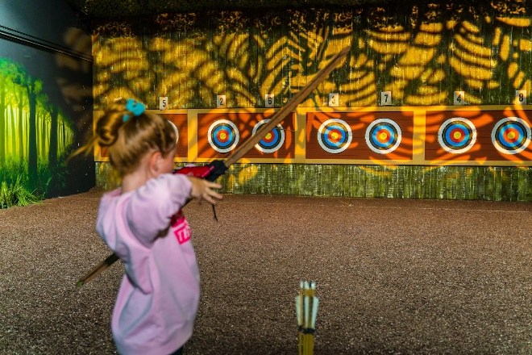
(Archery at The Bear Grylls Adventure)
XX August 2023: For those avid watchers of Marvel movies, The Witcher and Game of Thrones, now is the perfect time to get inspired and discover the thrill of archery yourself*! Step into the shoes of some of your favourite characters and give yourself the chance to learn a new skill and practice your aim, under expert guidance and in a controlled environment at one of Archery GB activity partners across the UK.
Archery is an ideal way for film fans to spend a day in the life of their favourite character or simply spend quality time with loved ones. Celebrated as one of the most inclusive sports, archery is open to everyone, whatever their age, gender, or ability. Archery is the perfect activity for a fun day out for all the family over the summer holidays. It's not just a really exciting sport, but it’s also a great opportunity to learn a new skillset and get that rush of dopamine when you hit the target. The benefits of archery are numerous, from the thrill of learning a new skill to building strength and focus.
Archery is accessible to everyone whether you consider yourself sporty or not, practice will see your ability grow which is hugely rewarding. There is a plethora of studies that show how exercise is good for your brain health and it improves cognitive function, supporting mental health as well as strength and focus, there is also the additional bonus of screen free fun. In fact, exercise can even help ward off some types of age-related cognitive decline such as reduced hand-eye coordination and memory loss. While playing a sport may momentarily make you tired, it leads to greater alertness and focus offering in the longer term more energy, not less!
If this has drawn on your inner archer and you’d like to try the sport for yourself there are plenty of accredited archery partners available across the country. Archery GB have developed a scheme called Archery Activity Partners to support and develop archery businesses across the UK and grow the sport thanks to accredited instructors who are trained to provide a safe and fun experience for all. All organisations that are not currently affiliated with Archery GB as a club are welcome to join the Archery Activity Partner (AAP) programme.
Why not try archery at one of these great locations:
The Bear Grylls Adventure, Birmingham
Located in Birmingham, The Bear Grylls Adventure welcomes all archers, from those who have never picked up a bow and arrow to returning archers looking to perfect their aim. All archers will get a full briefing before being taken to the range by Archery GB accredited instructors for a 30-minute archery adventure. Having learnt the basics, your skills will be put to the test with a range of engaging challenges and games. From August 5th there will be special sessions dedicated for the young budding archer age 5-7, it offers a great introduction to the sport.
Archery at The Bear Grylls Adventure costs from £20 and includes a 30-minute archery session and free assault course entry, T&Cs apply. Only those aged 8 years and over can participate in archery at The Bear Grylls Adventure.
Joe’s Bows, Faversham in Kent
Set in the idyllic countryside upon Willow Farm, Joe’s Bows is ideal for getting active outdoors this summer. Families and friends can take to the outdoor range and enjoy an hour’s archery lesson under the guidance of the centre’s expert instructors, who will teach aspiring archers exactly what it takes to hit the target.
One hour’s archery costs £25 per person, including one spectator per paying archery attendee. For groups of 1 to 6 people, aged 8 years or over.
Ackers Adventure, Birmingham
With two archery ranges on-site, Ackers Adventure is the perfect place to release your inner superhero! Whether you fancy trying archery for the first time or coming along to improve your technique, Ackers Adventure’s archery instructors can adapt the session to suit the needs of the group.
Located in the heart of Birmingham with a floodlit range, archery sessions can also take place during the evening! The centre also offers Target Archery, which is the style of archery practised at the Olympics, where archers shoot a set number of arrows at targets set at specified distances on a flat surface.
One and half hours of archery costs from £24.50 per person. Further details can be found here.
Try Soft Archery at Home with Clickers
The Arrows soft archery home kits from Clickers (£84.00) provide hours of competitive fun, encourage the family to be more active and boost wellbeing, as well as providing a great introduction to the sport, making them the perfect gift for Christmas or anytime of the year!
Containing a bow, three suction-cupped arrows, an arm bracer, a special shooting target and reference card, the Arrows soft archery kits are safe for kids and can be used in the garden, creating an ideal reason to get outdoors as a family.
Those looking to take up archery after their first experience, should take a certified beginner’s course to learn how to shoot safely in a controlled club environment, under expert tuition. To find your local club, please visit the Start Archery website: https://startarchery.co.uk/start-my-journey/find-a-club.
To find your local Archery GB accredited have-a-go centre, please visit: Find an archery activity centre near me and learn to shoot (startarchery.co.uk)
Those looking to become part of the AAP can find more details here: Become an Archery Activity Partner with Archery GB (startarchery.co.uk)
-Ends-
Notes to Editors
*Anyone looking to try archery should do so under expert supervision provided by a qualified coach or accredited Archery GB instructor at an archery range.
Media Contacts - Spider
Sara Dagan - sara.dagan@wearespider.com / 07309781429
Rebekah Smith - rebekah.smith@wearespider.com
About Archery GB
Archery GB is the British body for all forms of archery in the UK, an inclusive sport which lends itself to all spectrums of the population - regardless of age, disability or gender. With 800 clubs and 38,000 members, Archery GB is affiliated to World Archery, British Olympic Association & British Paralympic Association.
About Start Archery
Start Archery is a dedicated resource to learning more about beginning archery, how to get involved in the sport and where to join a club. The website also offers a range of useful resources and information for schools, teachers and other interested parties. www.startarchery.co.uk

