BRITAIN’S ARCHERS SHOOTING FOR GOLD AT 2023 WORLD CUP
- GB team announced for 2023 Hyundai Archery World Cup
- Team includes current World Number 1 and World Number 2
- Competition takes place 18-23 April in Antalya, Turkey
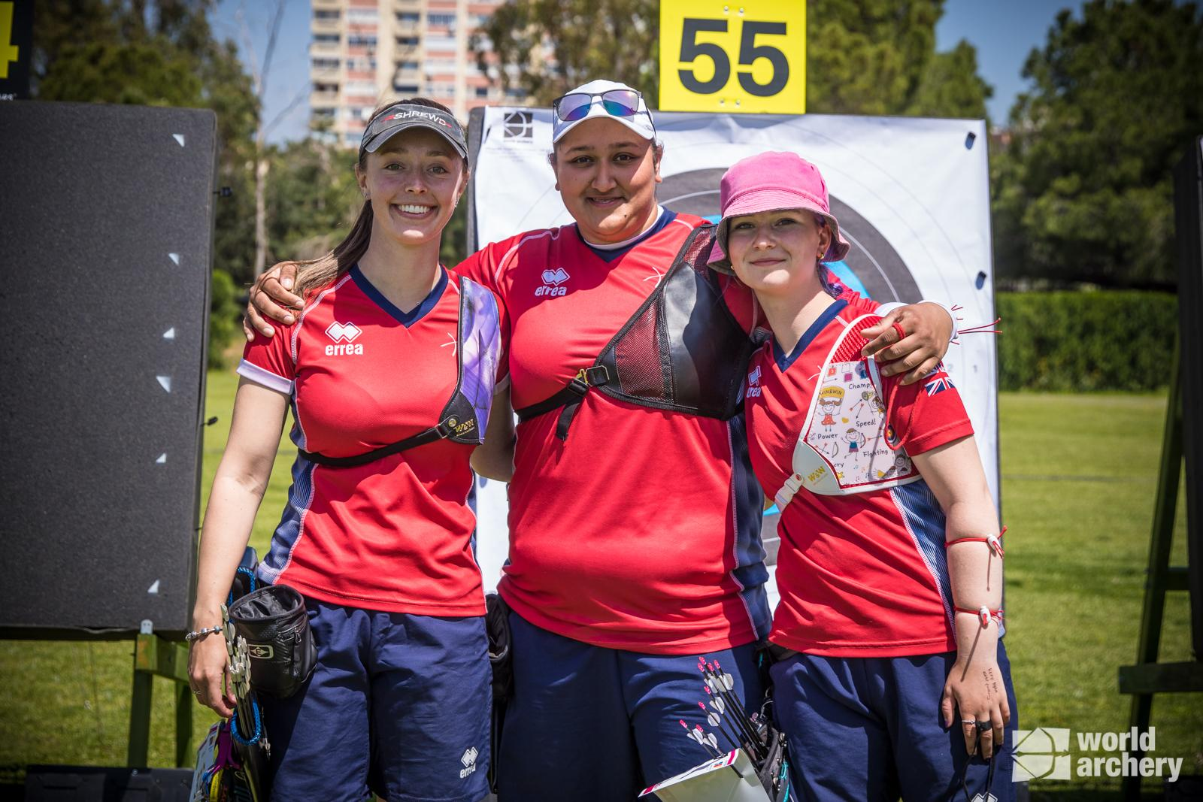
(Photos left to right: Bryony Pitman, Jaspreet Sagoo and Penny Healey (Credit World Archery).
XX March 2023: An impressive squad of eleven GB archers has been named ahead of the start of the first stage of the 2023 Hyundai Archery World Cup, which will take place in Antalya, Turkey this April.
Held annually, the revered Hyundai Archery World Cup brings together the best archers from across the globe to compete both individually and as teams throughout its four stages, with archers seeking to earn a place at September’s World Cup final in Mexico.
Having topped the medal table and achieving four impressive medals at 2022’s first stage, Great Britain’s archers will once again be looking to secure success in Antalya across both the recurve and compound disciplines.
Those competing for Great Britain in Antalya include:
Compound Women:
- Ella Gibson, Gloucestershire (Current World Number One Women’s Compound)
- Isabelle Carpenter, West Yorkshire
- Grace Chappell, Gloucestershire

Recurve Women:
- Bryony Pitman, Sussex (Current World Number Two Women’s Recurve)
- Penny Healey, Shropshire
- Jaspreet Sagoo, Cambridgeshire
- Sarah Bettles, Essex

Recurve Men:
- Monty Orton, Staffordshire
- James Woodgate, Surrey
- Alex Wise, Newcastle
- Tom Hall, Warwickshire
Following the squad’s announcement, Compound Programme Manager Jon Nott said, “I am very excited for our team to be on the World Cup trail for 2023. We very much believe that we can back up the success of 2022, and that our women’s team will be in the mix for medals all season. Antalya will be exciting as always to see how our preparations are going ahead of July’s World Championships.”
Women’s Recurve World Number Two, Bryony Pitman said, “I’m really excited to be heading back out to Antalya for the World Cup. We have a strong team and we’ve worked really hard this winter. It would be great to build on the success we had there last year.”
For more information on Archery GB and its performance teams, please visit archerygb.org
-Ends-
Notes to Editors:

The Hyundai Archery World Cup is archery's annual elite international competition. Consisting of four stages and a grand finale to which only the best athletes in each of the four international competition categories (Male/Female Compound and Male/Female Recurve) are invited.

The World Archery Championships will be held from 31 July - 6 August in Berlin, Germany.

Player Profiles:

Monty Orton: Monty started archery in 2016 after spending a couple of years sitting in a tent at competitions watching his younger brother Paddy shoot barebow. He was persuaded to give it a go and when he eventually agreed, he found he really enjoyed it. Monty signed up to a beginners’ course at Meriden Archery Club, joining their junior club where he had lots of fun and then ventured into some local competitions, gradually going further afield as time went on. He debuted for GBR in 2021 at the European Youth Cup, and, in 2022, won three golds at the European Youth Championships - the U21 individual and U21 team (with Charlie Medhurst and James Woodgate), and the U21 gold across both stages of the Cup.

James Woodgate: James is a member of Woking Archery Club, in Surrey. He made his Olympic debut at the Tokyo 2020 Games, finishing 33rd individually and 5th in the team event. He is studying physics at Warwick University whilst training. James ranked first at the World Youth Championships in the recurve junior men division, in 2021.
James topped the Recurve Men National Rankings in 2022. He was ranked 1st going into the National Tour Final where he finished 6th. He finished 4th at the European Youth Championships in the under 21 mixed team. He won gold as part of the men’s team at the same event and finished 6th in the individual event.

Alex Wise: Alex is studying Sport Development at Northumbria University and is originally from Newcastle. He first tried archery on holiday in Turkey and fell in love with it. Alex shoots for Bowmen of Walker, in Newcastle, and joined in 2015. He won Young Sporting Success of the Year at Sport Newcastle’s annual awards in 2020. He was part of the bronze winning team at the Archery World Cup in Antalya, 2018. He was part of the team that secured the full Olympic quota in 2019. He broke two National Records during the 2021 outdoor season, whilst also winning the British Target Championships. Alex won Mixed Team silver at the Antalya World Cup with teammate Bryony Pitman.

Tom Hall: Tom made his Olympic Debut at the Tokyo 2020 Games. He finished 33rd individually and fifth in the team. Tom has a PhD in Chemistry from the University of Warwick. He lives in Kenilworth, Warwickshire. He took up archery at university and has represented Great Britain at the World University Championships twice and World University Games once. He was part of the bronze winning team at the Archery World Cup in Antalya, 2018. Tom competed at the European Indoor Championships in February 2022 finishing 6th.

Penny Healey: Penny is the youngest on the squad, at just 18 years old. She started archery when she was 9, after watching the Disney movie “Brave”. It inspired her to have a go at archery, as it looked enjoyable and she used to do horse riding. Penny did her beginners course at Audco Archers. Penny’s proudest achievement to date is winning the Indoor World Series Finals in 2022 in Las Vegas. Along with shooting the European junior, national senior and junior WA720 record.

Bryony Pitman: Current Recurve World Number 2 Bryony won individual gold at the World Cup in Antalya, along with Mixed Team Silver with Alex Wise and Gold in the Women’s Team with Penny Healey and Jaspreet Sagoo. She also won individual silver at the Birmingham 2022 World Games and the World Archery Field Championships 2022 and silver as part of the women's recurve team at stage 4 of the World Cup. Bryony made her Olympic debut at the Tokyo 2020 Games, finishing ninth both individually and in the women’s team. Bryony was also part of the bronze winning team at the 2019 World Archery Championships. In 2019 she also won gold as part of the women’s recurve team at the European Games, Minsk. She has previously competed at the Summer Youth Olympics. Bryony lives in Shoreham, West Sussex. She’s a graduate in History from Northumbria University and is now studying for a Masters degree in Intelligence and Security from Brunel University.

Jaspreet Sagoo: Jaspreet, also known as Jess, was always sporty growing up with netball and basketball being her main sports before finding archery. She got introduced to archery when she was 16 and is now with Peacock Archers who are based just outside of Cambridge.

There have been several real ‘high points’ that have helped to keep Jaspreet motivated and move forward with her shooting. The one arrow shoot-off against Naomi Folkard in 2019 to win her first National Tour, winning the UK Masters in 2021, medaling in her fourth NT Finals and joining the PAPP at the end of 2021. She also won gold in the women’s recurve team event with her teammates Penny Healey and Bryony Pitman in her first World Cup appearance and silver as part of the women's team at a later stage.

Sarah Bettles: Sarah made her Olympic debut at the Tokyo 2020 Games, finishing 17th individually, ninth in the team and eighth in the mixed team. She won gold in the women’s recurve team event at the 2019 European Games, Minsk. She was part of the team that won bronze at the World Archery Championships in 2019, in Den Bosch, Netherlands. She has a Master’s in Biomedical Engineering from Cardiff University and has worked as an engineer before putting her career on hold to become a full-time athlete. She is originally from Essex but now lives in Telford, Shropshire. Sarah is a keen horserider in her spare time and also competed in trampolining before taking up archery.

Ella Gibson: Current World Number 1 Ella first tried archery in October 2014 when some coaches from Xperience archery came to her secondary school. They put on a six-week taster session after school and that led to a beginners’ course with Deer Park Archers and she joined the club in June 2015. Ella has competed internationally since 2018, winning a silver at the European Outdoor Championships, bronze at the Lancaster Classic and team medals on the World stage.
In February, 2022, her first big win individually on the international stage came when she took gold and the compound women European Indoor Champion title in Slovenia. In the same year she won the National Tour Final, individual gold at stages 1, 3 and 4 of the World Cup and silver in the World Cup Final. Ella won gold at the Birmingham 2022 World Games. As part of the women’s team, she won gold at the European Championships and silver at World Cup stages 3 and 4. She won bronze as part of the mixed team at the third stage of the World Cup.

Isabelle Carpenter: Izzy first started archery when she was ten years old, having tried the sport on a family holiday. Izzy, from Huddersfield, placed 5th at the 2021 Yankton Senior World Championships with the Compound Women’s Team.
Having completed a Master’s Degree in creative writing in 2021, she not only competes internationally for Great Britain but is also the Events Marketing Officer for Archery GB.
Her biggest achievements are becoming the 2022 European champion for compound women and the team champion. Her goal for the 2023 season is to go to the World Championships and better her world ranking.

Grace Chappell: Grace Chappell is from Gloucester and is a member of Deer Park Archers and Canford Magna Bowman. Grace did rifle shooting for 9 months, then a beginner’s course in archery. Her biggest achievement so far is Individual bronze at the European Youth Outdoor Championships. Her goal is to go on one senior trip in 2023 to gain experience.
She is currently in her second year studying a BA in graphic design at Arts University Bournemouth. Grace enjoys looking after her houseplants as well as watching TV and movies with her housemates in her spare time.

Media Contacts - White Tiger PR - Archery@whitetigerpr.com
Leanne Barton / Leanne.barton@whitetigerpr.com / 07867332590
Kimberley Powles / kimberley.powles@whitetigerpr.com / 07966 867827

Hi-res images are available from Dropbox with credit

About Archery GB
Archery GB is the British body for all forms of archery in the UK, an inclusive sport which lends itself to all spectrums of the population - regardless of age, disability or gender. With over 820 clubs and over 34,400 members, Archery GB is affiliated to World Archery, British Olympic Association & British Paralympic Association. More information www.archerygb.org. Beginners can visit www.startarchery.co.uk to find beginners’ courses and clubs near them and to learn more about the sport.

