GB ARCHERS SHOWCASE THEIR SKILLS ON HOME SOIL AT THE NATIONAL TOUR FINAL
- 18-year-old Penny Healey’s impressive season continues as she takes third consecutive gold medal in the recurve women’s category
- Lizzie Foster, Tom Hall and James Mason also took top podium spots
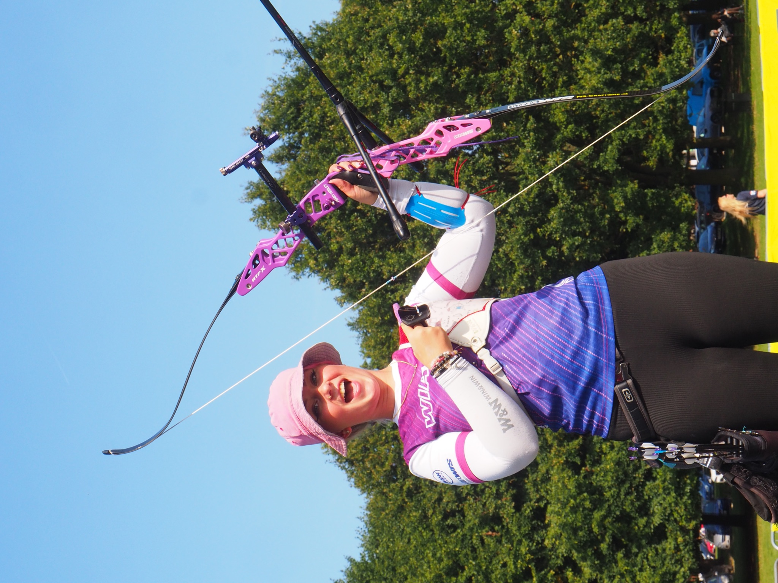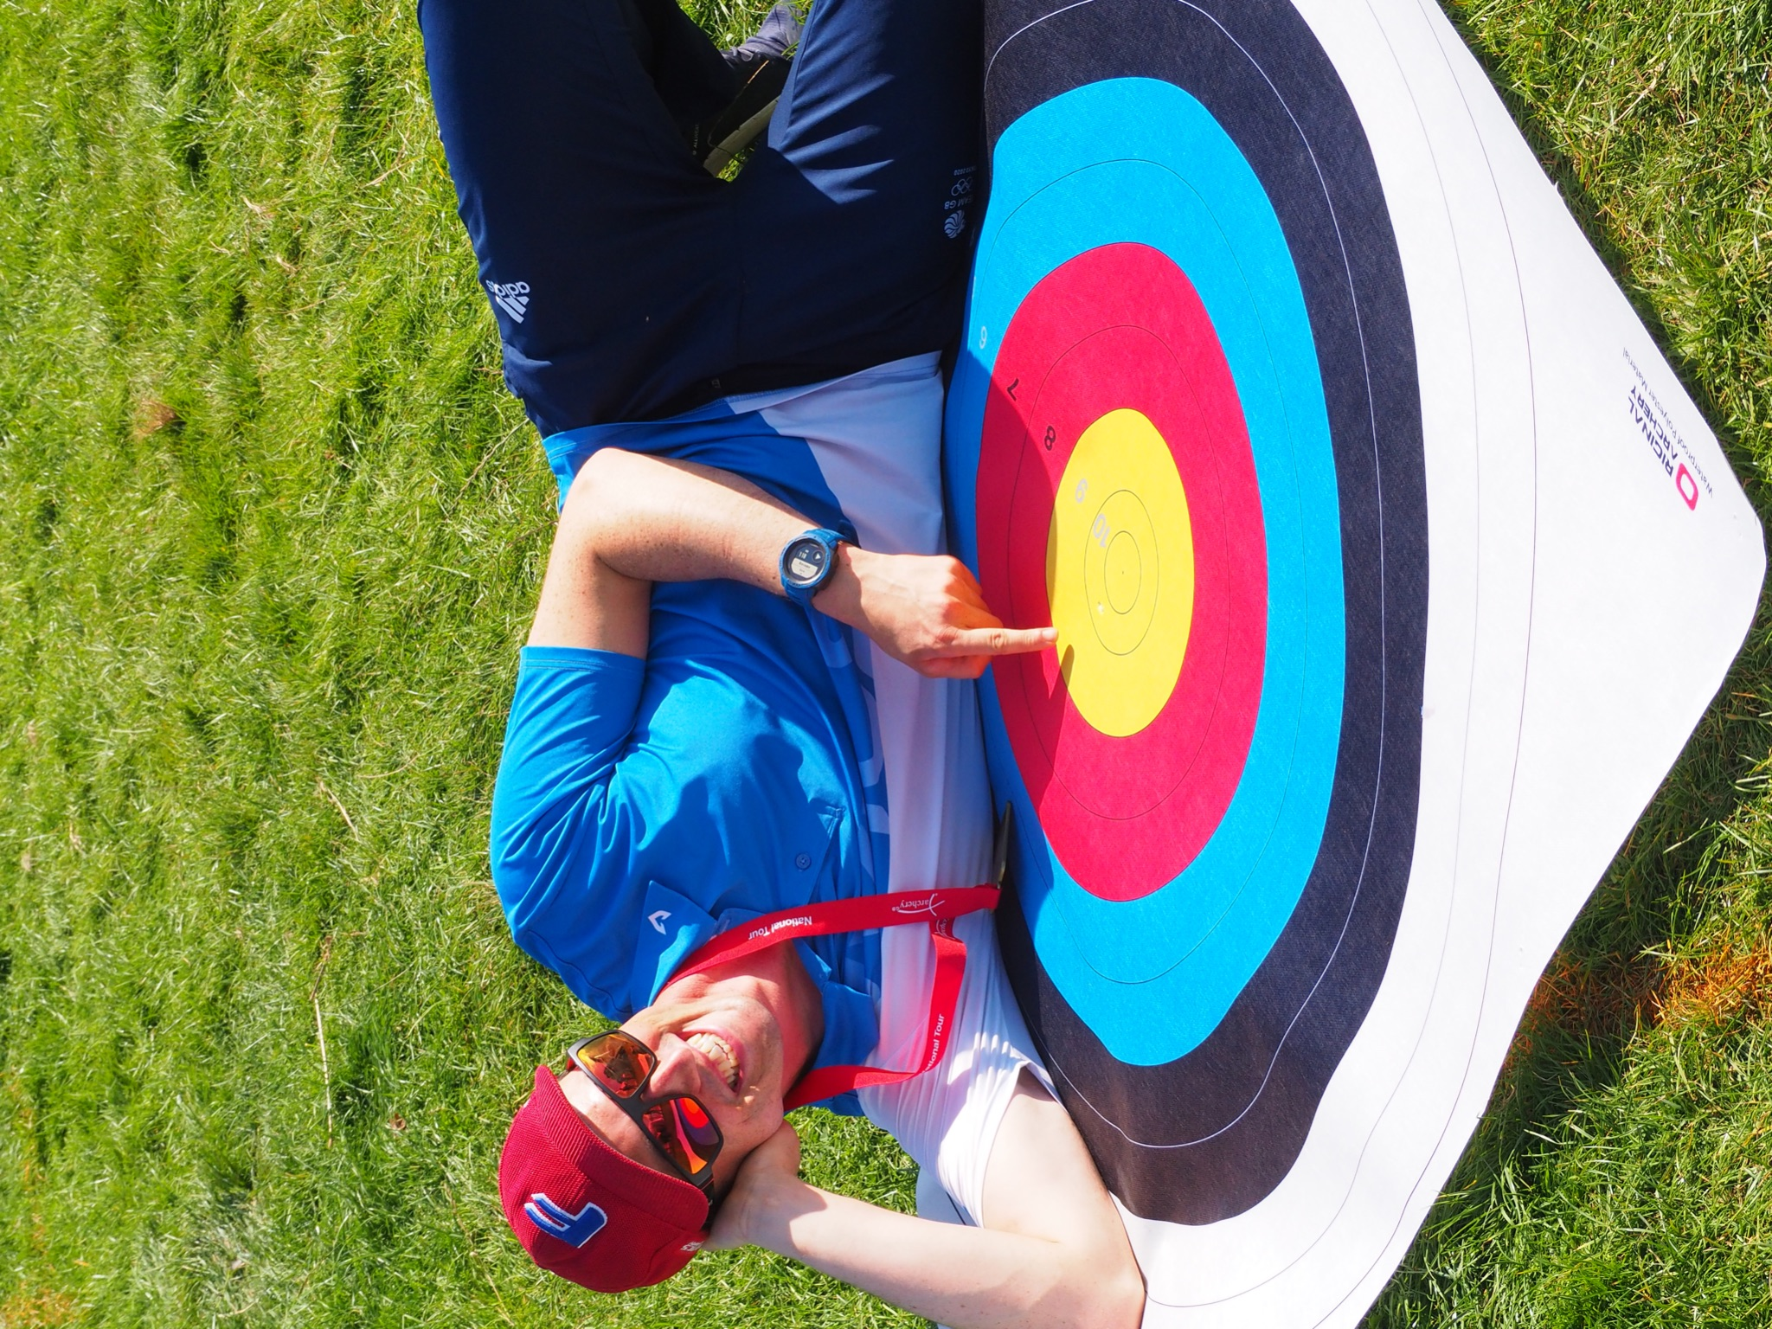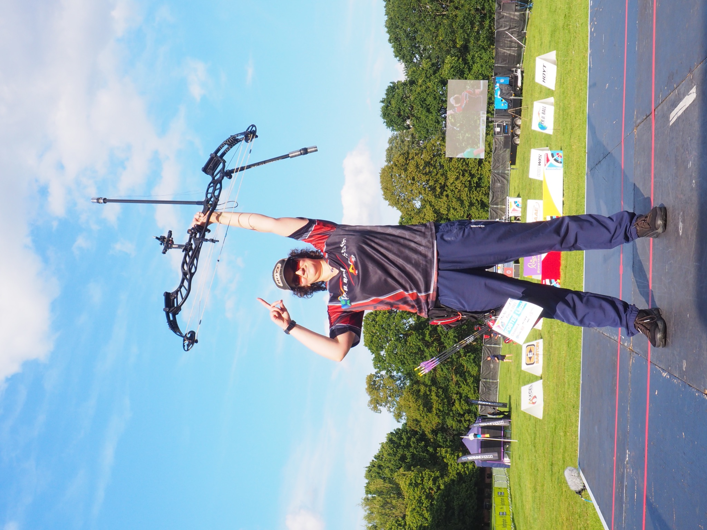
(Image credits: Left - Right Penny Healey, Tom Hall and Lizzie Foster celebrate their victories. Credit Archery GB)
XX September 2023: On the 2nd and 3rd September, the cream of the UK’s archery talent assembled at Wollaton Hall in Nottingham for the National Tour Finals. More than 6,000 spectators attended or streamed the event from across the world as they watched the archers compete for the top podium spots in the disciplines of recurve, compound and barebow archery.
18-year-old world number one Penny Healey secured gold in the recurve women event, taking her third National Tour title in a row, to add to her World Cup Antalya 2023 gold medal and her win at the European Games in Krakow. Sarah Bettles improved on her 2022 National Tour bronze medal to take the silver, and British Olympian Bryony Pitman picked up bronze.
After her victory, Penny said: “This win means a lot. I've been struggling a bit for the past few months with my shot routine and stuff, and to finally have it come together on the finals field is amazing and it gives me great confidence for the World Cup Final next week.”
In the recurve men competition, Tom Hall shot his way through to the gold, beating Conor Hall who took silver and Monty Orton the bronze.
Afterwards, Tom shared how he conquered his nerves to take the National Tour title, he said: “Just trust it. That's all I'm trying to scream into myself. When you're out there and you feel nervous and you're on the stage, everything is magnified. I've learned to just try to ignore it, find my shot, move through, and trust that the work I've done will get the results.”
In the compound competition, the women’s title was won by Lizzie Foster who saw off world number one Ella Gibson in an incredibly tight semi-final to face Layla Annison for the gold medal, with Gibson taking the bronze medal.
A shocked Lizzie said afterwards: “I’ll be honest, I don’t at this point quite realise what I’ve done. So maybe it’ll sink in tomorrow when I wake up and watch the video back and realise I have a gold medal around my neck.”
The compound men’s competition was won by 2018 and 2019 winner James Mason, Ajay Scott took the silver medal and last year’s second-placed shooter Kai Thomas-Prause took the bronze.
Speaking after his win, James said: “This win feels really good. It’s a big shock to be honest as I spent most of the season recovering from injury, so I went in with little expectations.”
The barebow competition saw an impressive rise in competitor numbers this year compared to 2022. In the barebow men competition, Daniel Kilgallon saw off competition from last year’s champion Wilco van Kleef-Bolton to win gold.
The barebow women’s event saw Sarah Hubbard fight hard to her first Tour Final gold medal; she beat Pat Hotchkiss to take the top spot.
This was the seventh time the two-day National Tour competition has been held at Wollaton Hall.
-ends-
Notes to Editors

Hi-Res images (Image Credits: Archery GB)

Athlete Profiles:

Penny Healey: Penny is the youngest on the national squad, at just 18 years old, and is known not only for her astounding talent, but her penchant for pink and purple hair.
She started archery when she was 9, after watching the Disney movie “Brave”. The teenager shot to the top of the world rankings for women’s recurve following an awe-inspiring gold medal win at the Antalya 2023 Hyundai Archery World Cup Stage 1 in April.

Just days earlier Penny also won the gold medal in women’s recurve at the European Grand Prix, held on home soil at Lilleshall, Shropshire.
She is still currently ranked world number 1.

Tom Hall: Tom made his Olympic Debut at the Tokyo 2020 Games. He finished 33rd individually and fifth in the team. Tom has a PhD in Chemistry from the University of Warwick. He lives in Kenilworth, Warwickshire. He took up archery at university and has represented Great Britain at the World University Championships twice and World University Games once. He was part of the bronze winning team at the Archery World Cup in Antalya, 2018. Tom competed at the European Indoor Championships in February 2022 finishing 6th.

Lizzie Foster: Lizzie is originally from South Tyneside where she was a member of Cleadon Archers. She took a beginners’ course when she was 12/13 after she bugged her dad for a long time, but only shot for three months. She picked it back up at the age of 17 for her university application. Liz’s goals for the year are “to be better than I was yesterday, and to not let people down that have invested in me”. She works for a software company and is currently working with the NHS Supply Chain as a Business Analyst. She now lives in Warwickshire.
In 2022 she competed at stages 3 and 4 of the World Cup winning silver at both events as part of the women’s team. She also finished 7th in the National Tour Final.

James Mason: James Mason shoots at Blackthorn Bowmen. He started shooting in 1993. James’s sister was the first person in the household to try archery and then his dad got heavily into the sport when his rugby days were coming to an end. James’s biggest achievements so far are winning 2 gold medals whilst representing Great Britain. He said the European Championships team with Neil Bridgewater and Adam Ravenscroft was an amazing experience in 2018. He also won mixed team gold at the World Cup in 2019 alongside Ella Gibson, which was the first World Cup gold medal GB had won for quite a few years. His proudest achievement was winning the AGB National Indoor Championships in 2013. It was a tough win, he had a lot of hard-fought matches, and he won one arrow shoot-off in the quarter-final, semi-final and final; his first big win as a senior.

Media Contacts: Spider PR - Archery@wearespider.com
Rebekah Smith / Rebekah.Smith@wearespider.com / 07840 104801

About Archery GB
Archery GB is the British body for all forms of archery in the UK, an inclusive sport which lends itself to all spectrums of the population - regardless of age, disability or gender. With over 820 clubs and over 34,400 members, Archery GB is affiliated to World Archery, British Olympic Association & British Paralympic Association. More information www.archerygb.org. Beginners can visit www.startarchery.co.uk to find beginners’ courses and clubs near them and to learn more about the sport.

