GB’S FEMALE ARCHERS SECURE THREE MEDALS AT THE 2022 WORLD CUP STAGE 4 IN MEDELLIN
- Ella Gibson takes Compound Women’s Individual gold
- Compound Women’s Team win silver
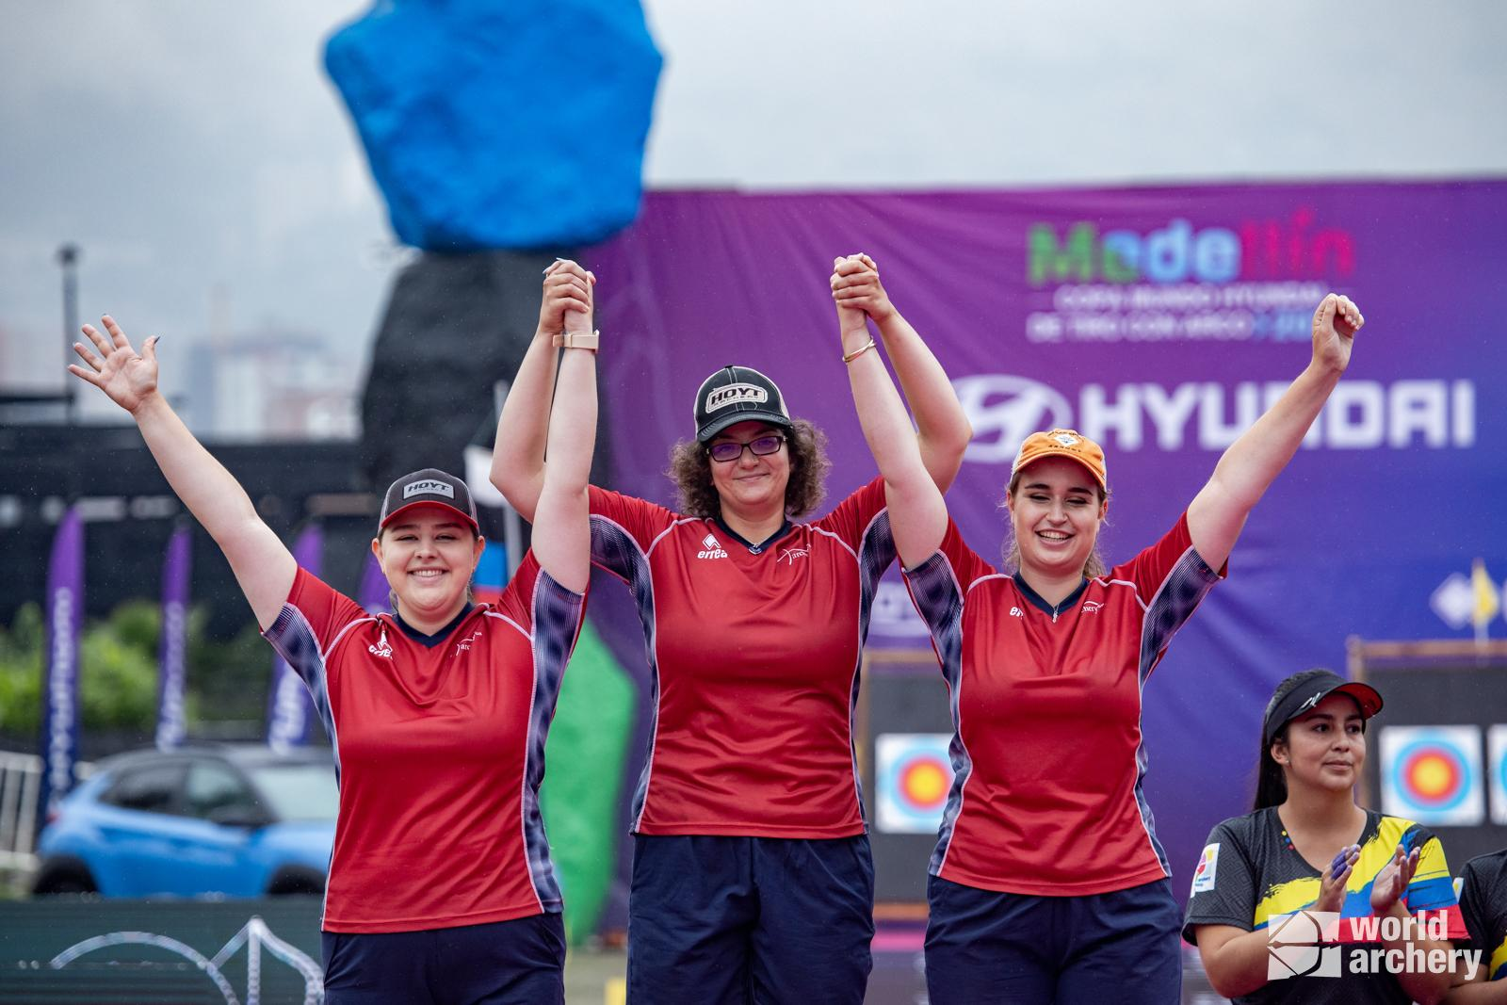
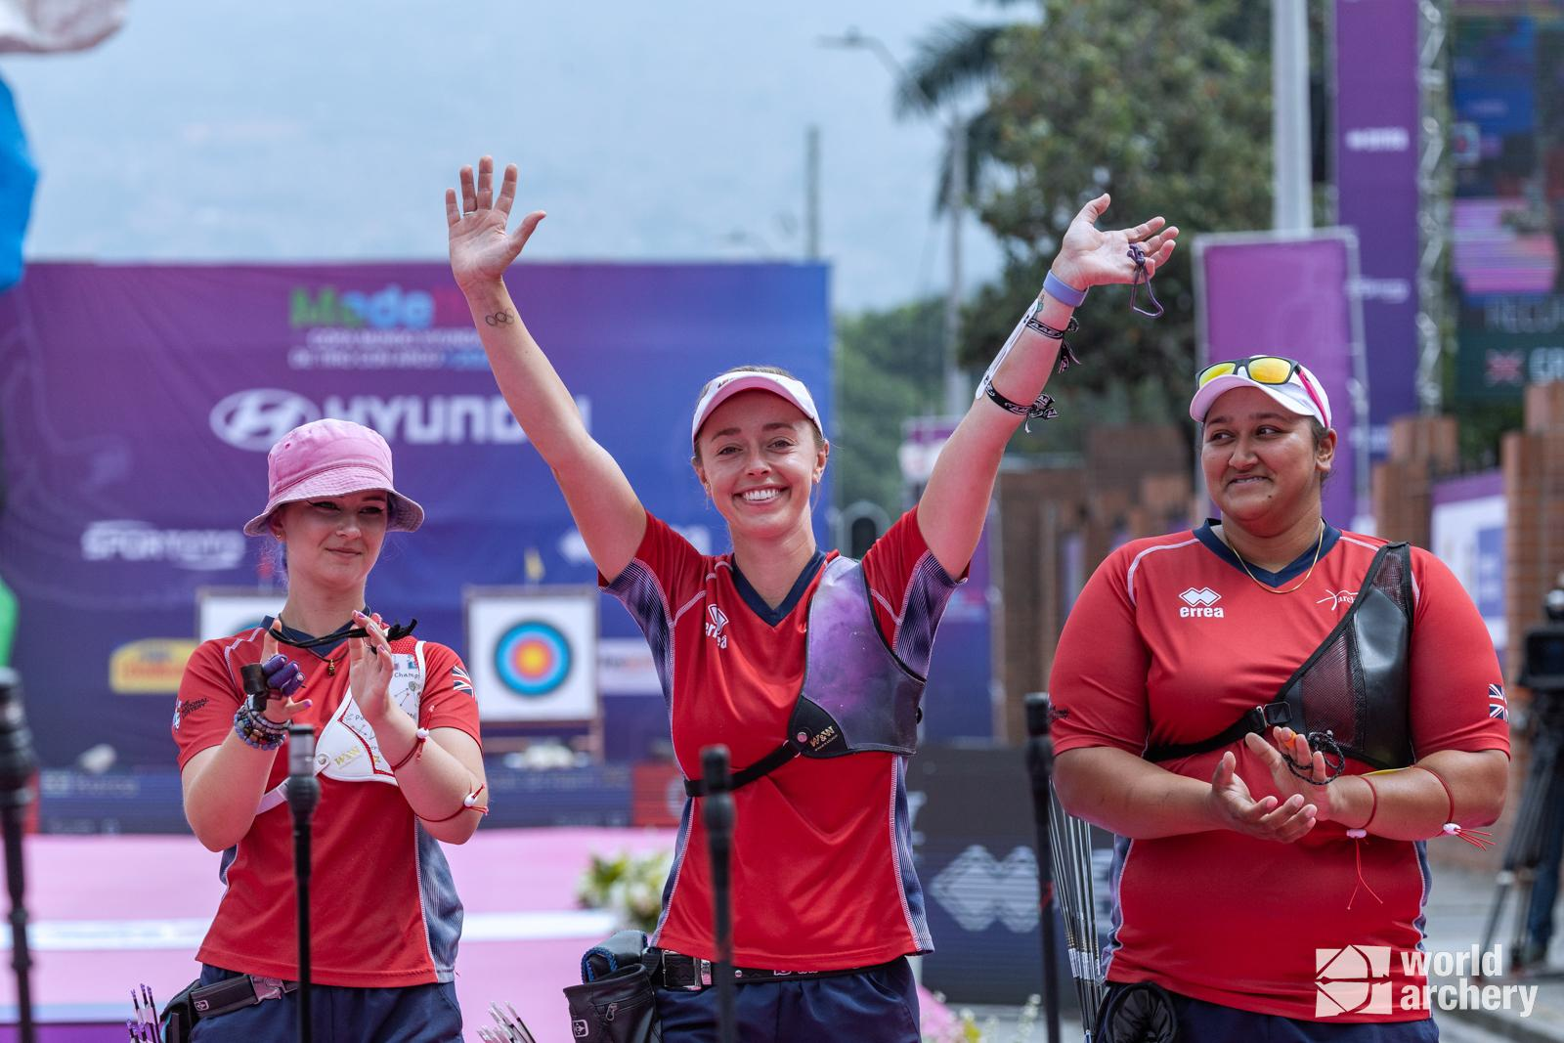
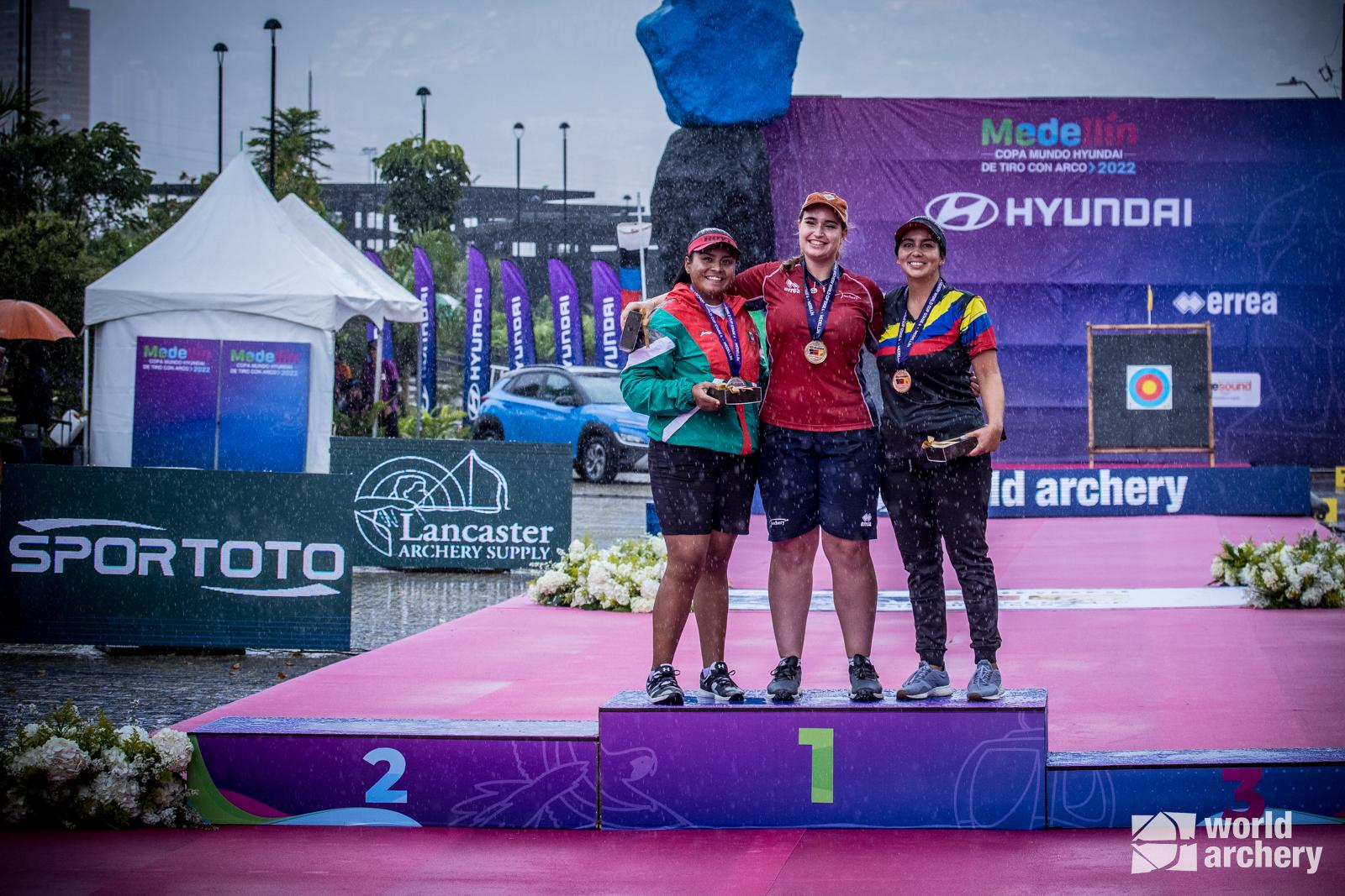
- Recurve Women’s Team secure silver
(Photos left to right: Ella Gibson takes gold in Medellin, Compound Women’s Team win silver, Recurve Women’s Team win silver.
Photo credits: World Archery)
25 July 2022: Great Britain’s female archers secured three medals at the Medellin 2022 Hyundai Archery World Cup Stage Four this weekend.
22-year-old Ella Gibson, from Gloucestershire, won gold in the Compound Women’s Individual matches, adding another medal to her 2022 competition success and making her the first Hyundai Archery World Cup triple-stage winner since 2016.
Ella Gibson, Liz Foster and Isabelle Carpenter won silver in the Compound Women’s Team events.
Bryony Pitman, Penny Healey and Jaspreet Sagoo took silver in the Recurve Women’s Team events, adding to the successful year GB’s archers have had to date.
Ella Gibson wins gold in Medellin after taking number one spot in World Rankings
Having beaten Sara Lopez, then world number one, at the 2022 World Games in Birmingham, USA, Gibson took the number one spot in the World Rankings in the Women’s Compound category earlier this month. Prior to the competition in the USA, Gibson ranked as number two, just 3.5 points behind Columbia’s Lopez.
Competing against each other for the first time since the 2022 World Games, Gibson and Lopez took to the field to shoot against each other in the Semi Final. Following a very close round, Gibson won with 148 to Lopez’s 146, securing herself a place in the gold medal match.
Gibson went on to compete against Mexico’s Dafne Quintero in the final on Saturday, winning with a score of 147 and securing yet another 2022 gold for herself and Great Britain.
On her latest medal win, Gibson said, “I became world number one at the beginning of last week [and] that puts a lot of expectation on yourself.”
“You still want to be able to perform, show that you do deserve that place in the ranking, that it isn't a one off, a fluke or anything like that. It was really important for me to come out and, not necessarily win today, but to shoot really well and show that this is how I shoot.”
“I feel amazing. I mean, I knew it was going to be some really hard matches. Having a semifinal against Sara was definitely an anxious, hard one, but I'm really happy with how I shot."
2022 has been an exceptional year to date for Gibson, who won multiple medals at the Paris 2022 Hyundai Archery World Cup Stage 3 competition in June - including gold in the Individual Women’s Compound matches.
Silver for the Women’s Compound Team
The Women’s Compound Team took silver in Medellin, after reaching the final against Columbia on Saturday.
Great Britain’s Isabelle Carpenter, Ella Gibson and Liz Foster beat the Republic of Korea in the Semi Final, in a close match that saw scores of 233 and 232, securing their spot in the final.
Liz Foster and Ella Gibson were also part of the silver medal winning Women’s Compound team, alongside Layla Annison, at the Paris 2022 Hyundai Archery World Cup Stage 3 competition in June.
GB’s Women’s Recurve Team take Silver
Having beaten Mexico in the Semi Final of the Recurve Women’s Team events, Bryony Pitman, Penny Healey and Jaspreet Sagoo went on to compete against the Republic of Korea in the gold medal match, before securing themselves silver.
In April, Pitman, Sagoo and Healey, who at the time were shooting together as a team for the first time, secured gold at the Antalya 2022 Hyundai Archery World Cup stage 1.
-ends-
Notes to Editors
Ella Gibson: Ella first tried archery in October, 2014, when some coaches from Xperience archery came to her secondary school. They put on a six-week taster session after school and that led to a beginners’ course with Deer Park Archers and she joined the club in June, 2015. Ella has competed internationally since 2018, winning a silver at the European Outdoor Championships last summer, bronze at the Lancaster Classic and team medals on the World stage. In February, 2022, her first big win individually on the international stage came when she took gold and the compound women European Indoor Champion title in Slovenia. Ella’s family own and run Dolcetti Ice Cream, in Cirencester. They are moving to bigger premises, which will have a 25-metre indoor range so that Ella can continue to shoot, whatever the weather.
Penny Healey: Penny is the youngest on the squad, at just 17 years old. She started archery when she was 9, after watching the Disney movie “Brave”. It inspired her to have a go at archery, as it looked enjoyable and she used to do horse riding. Penny did her beginners course at Audco Archers. Penny’s proudest achievement to date is winning the Indoor World Series Finals in 2022 in Las Vegas. Along with shooting the European junior, national senior and junior WA720 record. Her advice to archers is to work hard and enjoy what you do. “You shoot your best when you're having fun, and the hard work is what helps you reach your full potential as an archer.” Penny’s goals for this year were to make the senior international team, put in some new personal bests and to medal internationally. Outside of archery, she likes to listen to music, and achieved her grade 5 for violin.
Liz Foster: Liz Foster is originally from Cleadon Archers in East Boldon, South Tyneside and now lives in Warwickshire. She took a beginners’ course when she was 12/13 after she bugged her dad for a long time, but only shot for three months. She picked it back up at the age of 17 for her university application. Liz’s goals for the year are “to be better than I was yesterday, and to not let people down that have invested in me”. She works for a software company and is currently working with the NHS Supply Chain as a Business Analyst.
Bryony Pitman: Bryony made her Olympic debut at the Tokyo 2020 Games, finishing ninth both individually and in the women’s team. Bryony was also part of the bronze winning team at the 2019 World Archery Championships. In 2019 she also won gold as part of the women’s recurve team at the European Games, Minsk. She has previously competed at the Summer Youth Olympics. Bryony lives in Shoreham, West Sussex. She’s a graduate in History from Northumbria University and studied for a Masters degree in Intelligence and Security from Brunel University. Bryony is a keen gym goer and is often at the Underground Gym in Brighton.

Penny Healey: Penny is the youngest on the squad, at just 17 years old. She started archery when she was 9, after watching the Disney movie “Brave”. It inspired her to have a go at archery, as it looked enjoyable and she used to do horse riding. Penny did her beginners course at Audco Archers. Penny’s proudest achievement to date is winning the Indoor World Series Finals in 2022 in Las Vegas. Along with shooting the European junior, national senior and junior WA720 record. Her advice to archers is to work hard and enjoy what you do. “You shoot your best when you're having fun, and the hard work is what helps you reach your full potential as an archer.” Penny’s goals for this year were to make the senior international team, put in some new personal bests and to medal internationally. Outside of archery, she likes to listen to music, and achieved her grade 5 for violin.

Jaspreet Sagoo: Jaspreet, whose teammates call her Jess, is originally from the East End of London. In her words, not somewhere you immediately think of as a breeding ground for archers! Jaspreet was always sporty growing up with netball and basketball being her main sports before finding archery. She was introduced to archery when she was 16 and found out she was quite good at it! Her family moved away from London a few years ago so she changed club. Jaspreet is now with Peacock Archers who are based just outside of Cambridge. Jaspreet said: “I am really lucky to be with a club that is fully supportive of me and my ambitions.” There have been several real ‘high points’ that have helped to keep Jaspreet motivated and move forward with her shooting. The one arrow shoot-off against Naomi Folkard in 2019 to win her first National Tour, winning the UK Masters in 2021, seeing her 720 scores consistently above 650 and medaling in her fourth NT Finals. But top of the list so far has to be joining the PAPP at the end of 2021. Outside of archery, Jaspreet is from a pretty traditional Sikh family, so there’s always loads of family things going on which keep her pretty busy when she’s not training or competing.

Media Contacts - White Tiger PR - Archery@whitetigerpr.com
Leanne Barton / Leanne.barton@whitetigerpr.com / 07867332590
Kate Bates / Kate.Bates@whitetigerpr.com / 07876803947
Kimberley Powles / kimberley.powles@whitetigerpr.com / 07966 867827

Hi-res images are available from Dropbox with credit World Archery HERE

About Archery GB
Archery GB is the British body for all forms of archery in the UK, an inclusive sport which lends itself to all spectrums of the population - regardless of age, disability or gender. With over 820 clubs and over 34,400 members, Archery GB is affiliated to World Archery, British Olympic Association & British Paralympic Association. More information www.archerygb.org. Beginners can visit www.startarchery.co.uk to find beginners’ courses and clubs near them and to learn more about the sport.

