SIX WORLD TOP SPOTS FOR GB’S YOUNG FEMALE ARCHERS
GB’s archers hold three individual world number one spots, two team top spots and one individual world number two spot
18-year-old Penny Healey is Women’s Recurve World Number one, with Bryony Pitman taking the number two spot

Ella Gibson retains top spot in Women’s Compound

Para archer Phoebe Paterson Pine holds world number one ranking in Compound Women Open
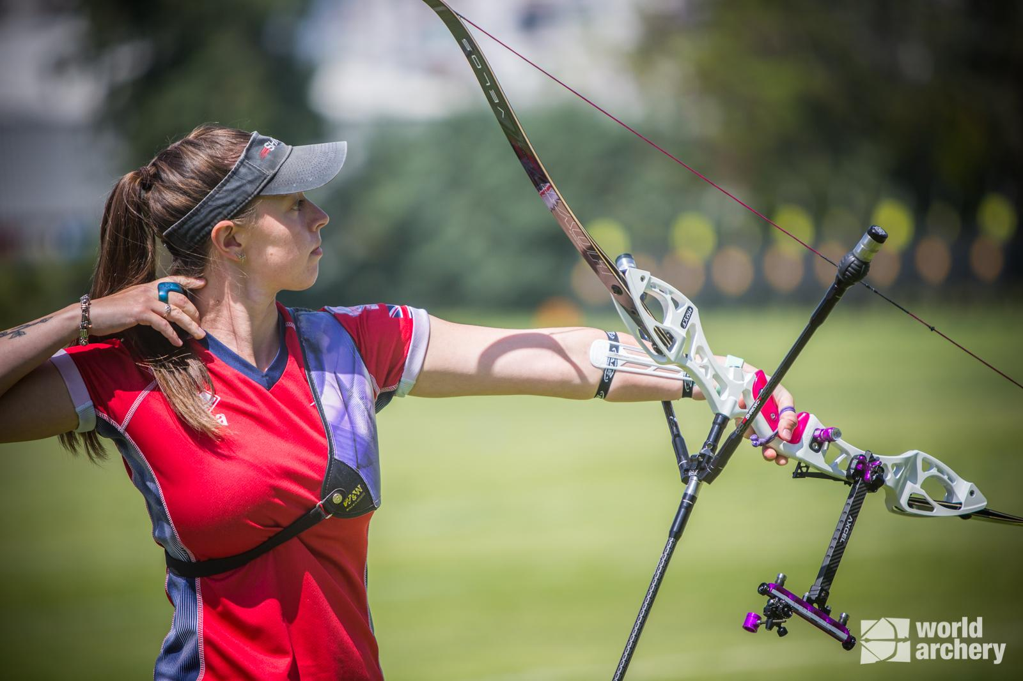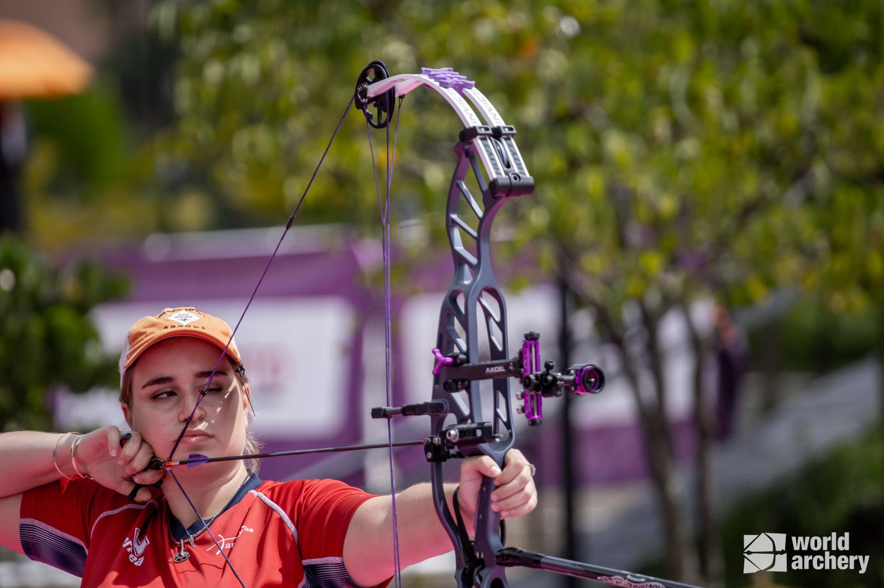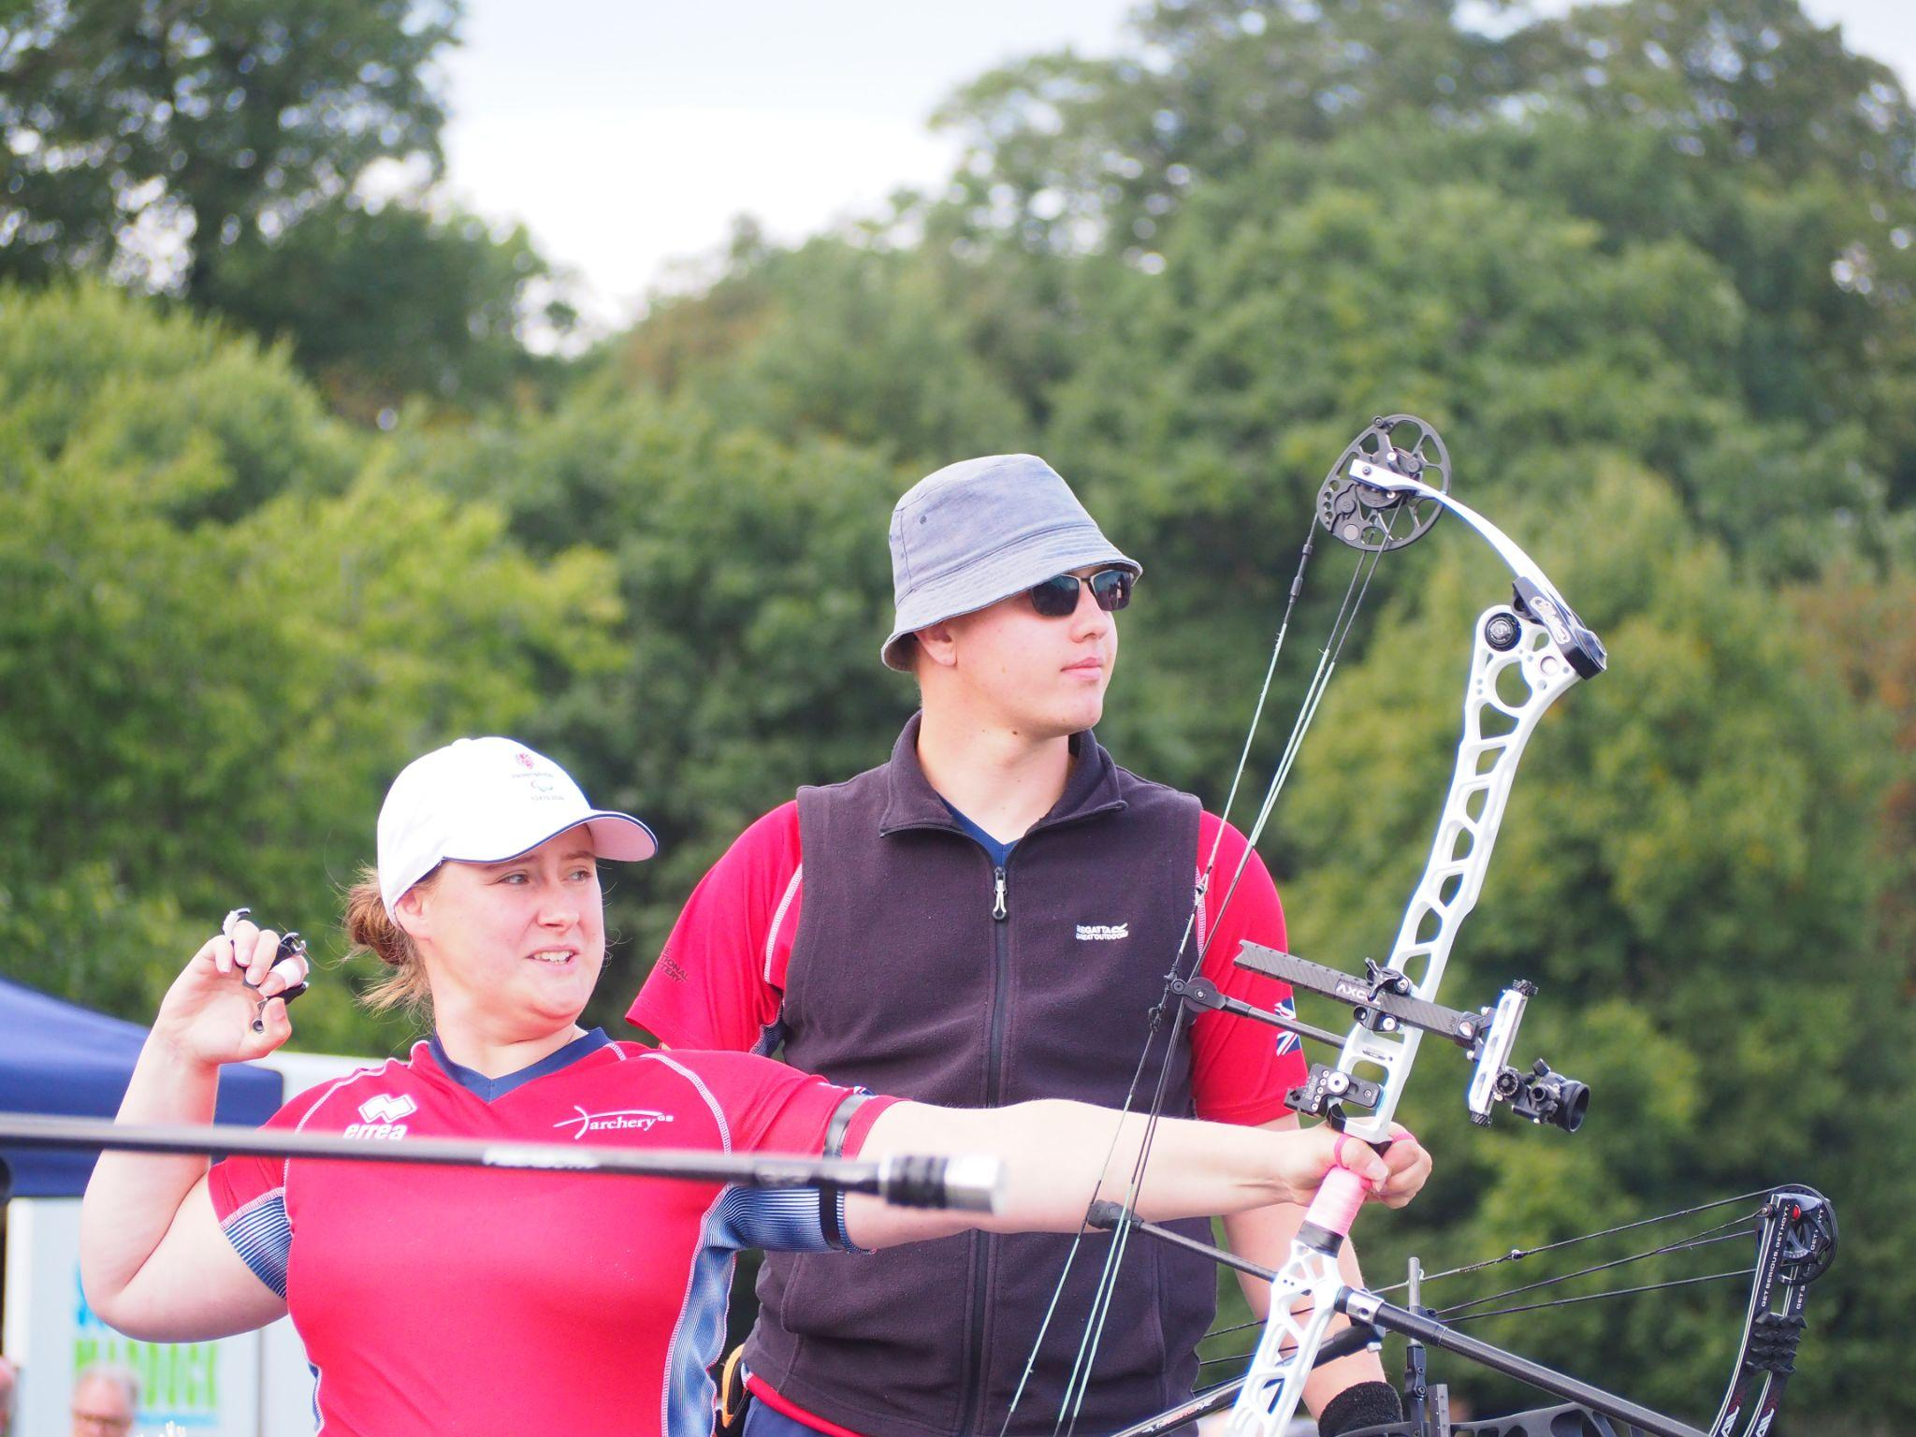
Left to right: Bryony Pitman (Photo credit: World Archery), Ella Gibson (Photo credit: World Archery), Phoebe Paterson Pine (Photo credit: Archery GB)
Interviews available on request - please email archery@whitetigerpr.com
June 2023: Great Britain’s female archers are truly leading the world of archery retaining three top spots in world rankings, as well as one number two spot – as well as a world leading Compound Women’s Team and Compound Mixed Team Open.
Following the 2022 success of Ella Gibson and Phoebe Paterson Pine, who took the world number one titles in Women’s Compound and Compound Women Open respectively, Penny Healey now holds the world’s top spot in Women’s Recurve - with teammate Bryony Pitman following closely behind ranking world number two.
What’s more, Great Britain’s Women’s Compound Team have taken the World Number One spot. With Compound archery being considered for inclusion in the 2028 Olympic Games (currently only recurve is included in Olympic archery), this fantastic achievement stands the GB female archers in good stead. There are six members of the GB women’s compound team, Ella Gibson, Izzy Carpenter, Lizzie Foster, Layla Annison, Grace Chappell and 2016 Paralympic gold medallist Jess Stretton. See the Women’s Compound team in action here: www.instagram.com/p/CtPQGyWLfPw/?hl=en.
In para archery’s Compound Mixed Team Open category, Great Britain once again holds the top spot. The team’s world number one ranking points were earned by Jess Stretton, Nathan Macqueen, Phoebe Paterson Pine and Jamie Harris.
The 2023 international competition season is underway, with two of the year’s largest events taking place in the coming weeks - the third stage of the Hyundai World Cup (13 to 18 June) and European Games (21st June to 2nd July).
This year has already seen some fantastic results for the archers with Penny Healey winning gold at the first stage of the World Cup, which resulted in her taking the number one spot. At the second stage in Shanghai, Ella Gibson earned silver, whilst Phoebe Paterson Pine took gold with teammate Jodie Grinham at European Para Cup that same month.
Meet the Archers:
Penny Healey - World Number One Women’s Recurve (Photo credit: Archery GB)
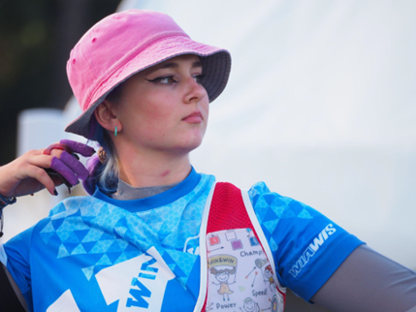
Penny is the youngest on the national squad, at just 18 years old, and is known not only for her astounding talent, but her penchant for pink and purple hair.
The teenager shot to the top of the world rankings for women’s recurve following an awe-inspiring gold medal win at the Antalya 2023 Hyundai Archery World Cup Stage 1 in April. Just days earlier Penny also won the gold medal in women’s recurve at the European Grand Prix, held on home soil at Lilleshall, Shropshire.
She started archery when she was nine, after watching the Disney movie “Brave”. It inspired her to have a go at archery, as it looked enjoyable, and she used to do horse riding.
Penny’s achievements to date include winning the Indoor World Series Finals in 2022 in Las Vegas. Along with shooting the European junior, national senior and junior WA720 record.
In December, at the National Indoor Championships, Penny broke the Under 18 Recurve Women 18m World Record, and matched the Under 21 Recurve Women 18m World Record, all while becoming the National Recurve Women’s Champion. She medalled twice as part of the women's recurve team winning gold and silver at different stages of the international Hyundai World Cup tournament. She also came first in the National Tour Final 2022.
Ella Gibson - World Number One Women’s Compound (Photo credit: World Archery)
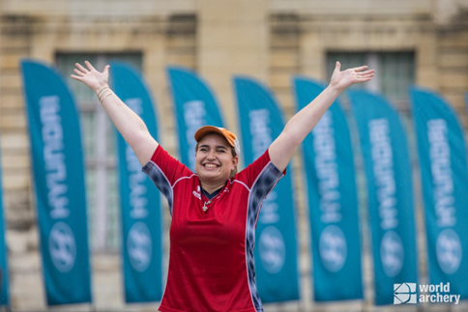
How many World Number 1’s train in an ice cream factory? We’re willing to bet that Ella Gibson is probably the only one. Ella’s family own and run Dolcetti Ice Cream, in Cirencester. They have recently moved to bigger premises, which includes a 25-metre indoor range so that Ella can continue to shoot, whatever the weather.
Ella first tried archery in October 2014 when some coaches from Xperience archery came to her secondary school. They put on a six-week taster session after school and that led to a beginners’ course with Deer Park Archers and she joined the club in June 2015. Ella has competed internationally since 2018, winning a silver at the European Outdoor Championships, bronze at the Lancaster Classic and team medals on the World stage.
In February 2022, her first big win individually on the international stage came when she took gold at the Compound Women European Indoor Champion title in Slovenia. In the same year she won the National Tour Final, individual gold at stages 1, 3 and 4 of the World Cup and silver in the World Cup Final.
Ella won silver at the Birmingham 2022 World Games. As part of the women’s team, she won gold at the European Championships and silver at World Cup stages 3 and 4. She won bronze as part of the mixed team at the third stage of the World Cup. Ella has broken several records and is currently World Number 1.
Phoebe Paterson Pine (MBE) - World Number One Compound Women Open Photo credit: ParalympicsGB)
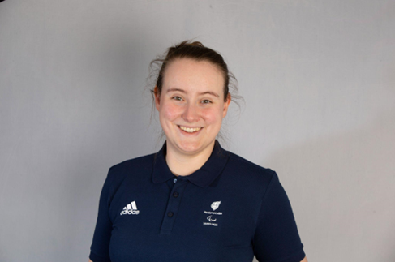
Phoebe is a gold medal Paralympian and current world number 1 and former junior indoor and outdoor national champion. She won gold at her Games debut in Tokyo winning the Compound Women Open and while she has been a member of the Archery GB para squad for some years, she has also now been named as a member of the Archery GB national compound squad.
She has spina bifida and first tried archery on a family holiday, enjoying it so much she joined her local club. Phoebe is a student at Worcester University, studying sports coaching science.
She holds multiple National, European and World records breaking five UK, European and World records over five days in 2022! She was appointed an MBE for her services to archery in the New Years Honours list 2022.
She won bronze individually at the World Archery Para Championships in Dubai 2022 and gold at the Disability Championships. She won gold at the 2022 European Para Archery Championships and the Para Archery European Cup in the individual Compound Women Open event as well as bronze as part of the mixed team with Jamie Harris also at the Para Archery European Cup.
Bryony Pitman - World Number Two Women’s Recurve (Photo credit: World Archery)
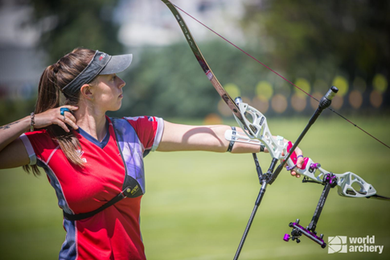
Bryony is currently World Number Two in women’s recurve, after a successful 2022 picking up various wins and gold medals at World Cup stages and competing in the World Cup Final.
Bryony made her Olympic debut at the Tokyo 2020 Games, finishing ninth both individually and in the women’s team. She was also part of the bronze winning team at the 2019 World Archery Championships and in 2019 she also won gold as part of the women’s recurve team at the European Games, Minsk.
Bryony lives in Shoreham, West Sussex. She’s a graduate in History from Northumbria University and studied for a Masters degree in Intelligence and Security from Brunel University - a considerable challenge when you’re jetting off to national and international competitions on a regular basis.
She is the first British recurve archer in the World Cup era to reach the number one spot in the world rankings, which she achieved briefly at the start of 2023. In the pre-World Cup era, Alison Williamson was world number one in 1999.
- ENDS -
Media Contacts: White Tiger PR - Archery@whitetigerpr.com
Leanne Barton / Leanne.barton@whitetigerpr.com / 07568 925069

About Archery GB
Archery GB is the British body for all forms of archery in the UK, an inclusive sport which lends itself to all spectrums of the population - regardless of age, disability or gender. With over 820 clubs and over 34,400 members, Archery GB is affiliated to World Archery, British Olympic Association & British Paralympic Association. More information www.archerygb.org. Beginners can visit www.startarchery.co.uk to find beginners’ courses and clubs near them and to learn more about the sport.

