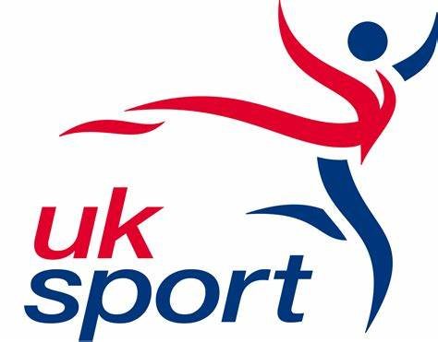
PARIS 2024: £3.6M PERFORMANCE ARCHERY CENTRE TO BE BUILT
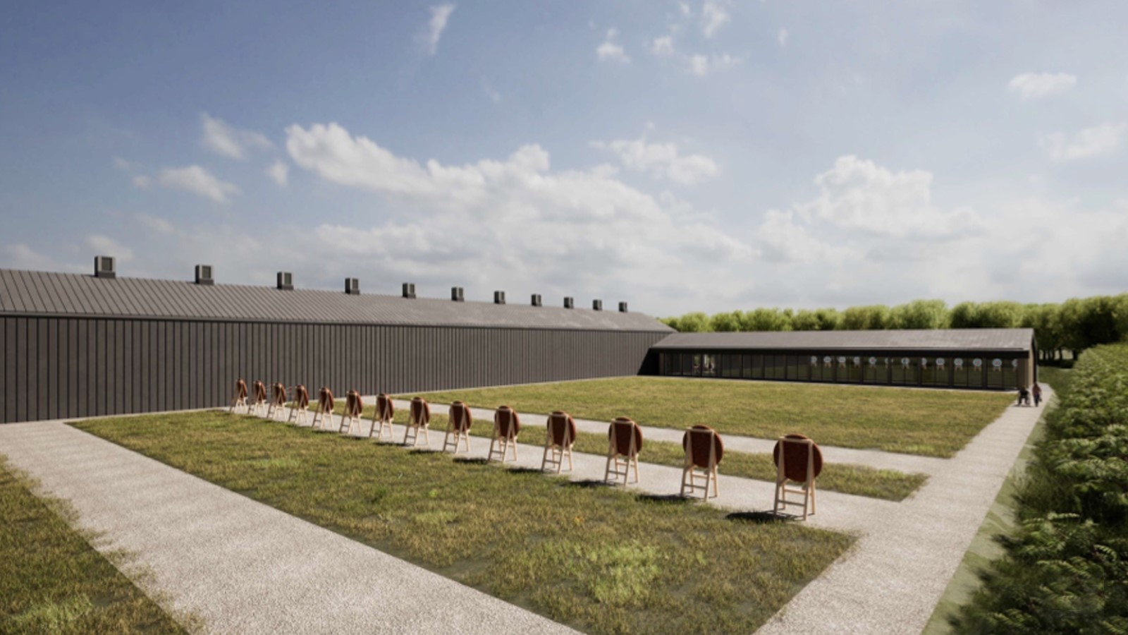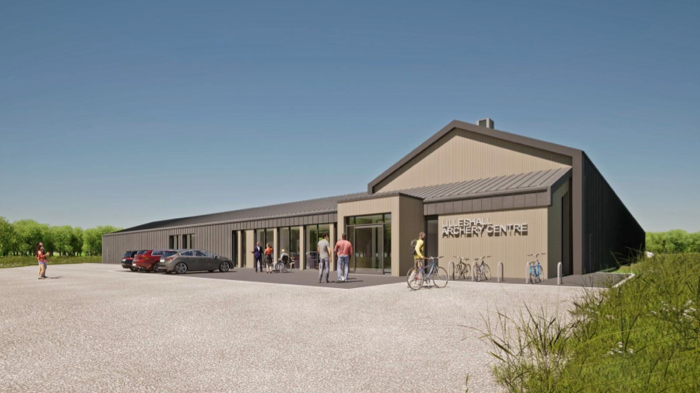
Photos: How the new performance archery centre will look. Credit: Darnton B3 (DB3) Architects
August 2023: Sport England are funding the construction of a new dedicated Performance Archery facility at their Lilleshall National Sports Centre. It will establish Lilleshall as the ‘Home of British Performance Archery’ used by Olympic and Paralympic archers as their daily elite training environment, Talent Pathway athletes aiming to get onto UK Sport’s World Class archery programme, the National Compound Squad, Audco Archers for their local club activities as well as regional and national community tournaments throughout the year.
Archery GB have been based at Lilleshall for over 20 years. Previously Sport England funded the re-purposing of a sports hall and synthetic football surface as an archery facility. Over time the environment couldn’t be further redeveloped to achieve the standards needed for a modern elite daily training environment. Adding a dedicated archery facility to Lilleshall’s onsite auxiliary facilities (elite athlete support services, catering, accommodation, conferencing and offices) means Lilleshall now provides a turn-key solution for all archery activities. The new facility will feature a 70m indoor and outdoor shooting range enabling all-year-round shooting, changing rooms, coaching and training support areas, toilets as well as car and cycle parking. Facilities will be on the same level and be fully inclusive and accessible for all abilities.
The facility has a number of green initiatives including an array of south-facing solar panels on the roof along with additional battery storage to ensure the benefit is gained all year-round. Hot water will be generated via air source heat pumps which are located externally to avoid the building requiring any kind of gas supply. The heat pumps ensure that the building increases its energy efficiency and reduces its carbon footprint.
Lisa Dodd-Mayne, Sport England Executive Director, Place, said: "Sport England are delighted to be investing in the construction of a new dedicated archery facility at our Lilleshall National Sports Centre.
"The facility retains archery as a key long-term site partner providing a world class archery daily training environment for UK Sport's World Class Programmes, talent pathway athletes as well as being accessible for the wider archery community and contributing towards Sport England's 'Uniting the Movement' strategy."

Dr Kate Baker, UK Sport’s Director of Performance, said: “We welcome the creation of this new centre. We are confident that it will provide superb support to the efforts of our Olympic and Paralympic archers as they prepare to shoot for success in Paris and beyond.

“The eco-friendly nature of the facility aligns strongly with UK Sport’s sustainability strategy, which includes a goal for Olympic and Paralympic sport to have a net positive impact on the environment by 2040.

“We look forward to this facility playing a key role in the development of top-level archery talent in the years ahead.”
The project is due to complete before the winter season to enable elite athletes the best possible preparations for next year’s Paris Olympic and Paralympic Games. The collaborative approach between Sport England, UK Sport, Serco and Archery GB to deliver this facility will mean Archery GB remains a long-term key partner at Lilleshall.
Tom Duggan, Archery GB’s Performance Director, said: “To have a purpose-built performance archery facility will be a massive step for the sport at Lilleshall and aligns with our ambitions to redefine performance archery.
“At a practical level, the new centre will increase the number of training hours we have access to, give us better continuity and flexibility around training and reduce the number of training days we lose as a result of the capacity limitations.
“We are extremely grateful for the support and investment from both Sport England and UK Sport in enabling this project to come to fruition and look forward to the impact that this can have on performance archery.
Steve Nelson, Serco Operations Director said; “As operators of Lilleshall National Sports Centre since 2011, we have supported Archery GB for well over a decade, during which time we have built a strong collaborative relationship.

“We’re delighted to see this project come to fruition for Archery GB and all the athletes it supports, who will be benefitting from this incredible new performance centre once it opens.”

Rob Lashford, Divisional Director at developers Speller Metcalfe who are building the centre, said: "To be working on this new state-of-the-art archery development for Sport England is an exciting opportunity for the company. It's great to see the investment into sport and that we can be a part of the continued success of our athletes in ensuring we build them a functional and efficient facility."
Lilleshall National Sports Centre is owned by the Sports Council Trust Company, a subsidiary of Sport England.

-Ends-
Notes to Editors:

About Archery GB
Archery GB is the British body for all forms of archery in the UK, an inclusive sport which lends itself to all spectrums of the population - regardless of age, disability or gender. With over 800 clubs and over 38,300 members, Archery GB is affiliated to World Archery, British Olympic Association & British Paralympic Association. More information www.archerygb.org. Beginners can visit www.startarchery.co.uk to find beginners’ courses and clubs near them and to learn more about the sport.

About Sport England
Sport England is a public body and invests up to £500 million National Lottery and government money each year in projects and programmes that help people get active and play sport. It
wants everyone in England, regardless of age, background, or level of ability, to feel able to engage in sport and physical activity.

About UK Sport
UK Sport is the nation’s high-performance sports agency investing in Olympic and Paralympic sport. Its mission is to work in partnership to lead sport in the UK to world class success.
Primarily this means working with our partner sporting organisations to deliver medals at the Olympic and Paralympic Games. UK Sport funds the athletes who are part of the World Class Programme who compete and represent GB on the world stage.

