GREAT BRITAIN’S FEMALE ARCHERS TAKE THREE WORLD NUMBER ONE SPOTS
- Bryony Pitman takes world top spot in Women’s Recurve
- Follows Ella Gibson and Phoebe Paterson Pine taking top spots in Women’s Compound and Compound Women Open
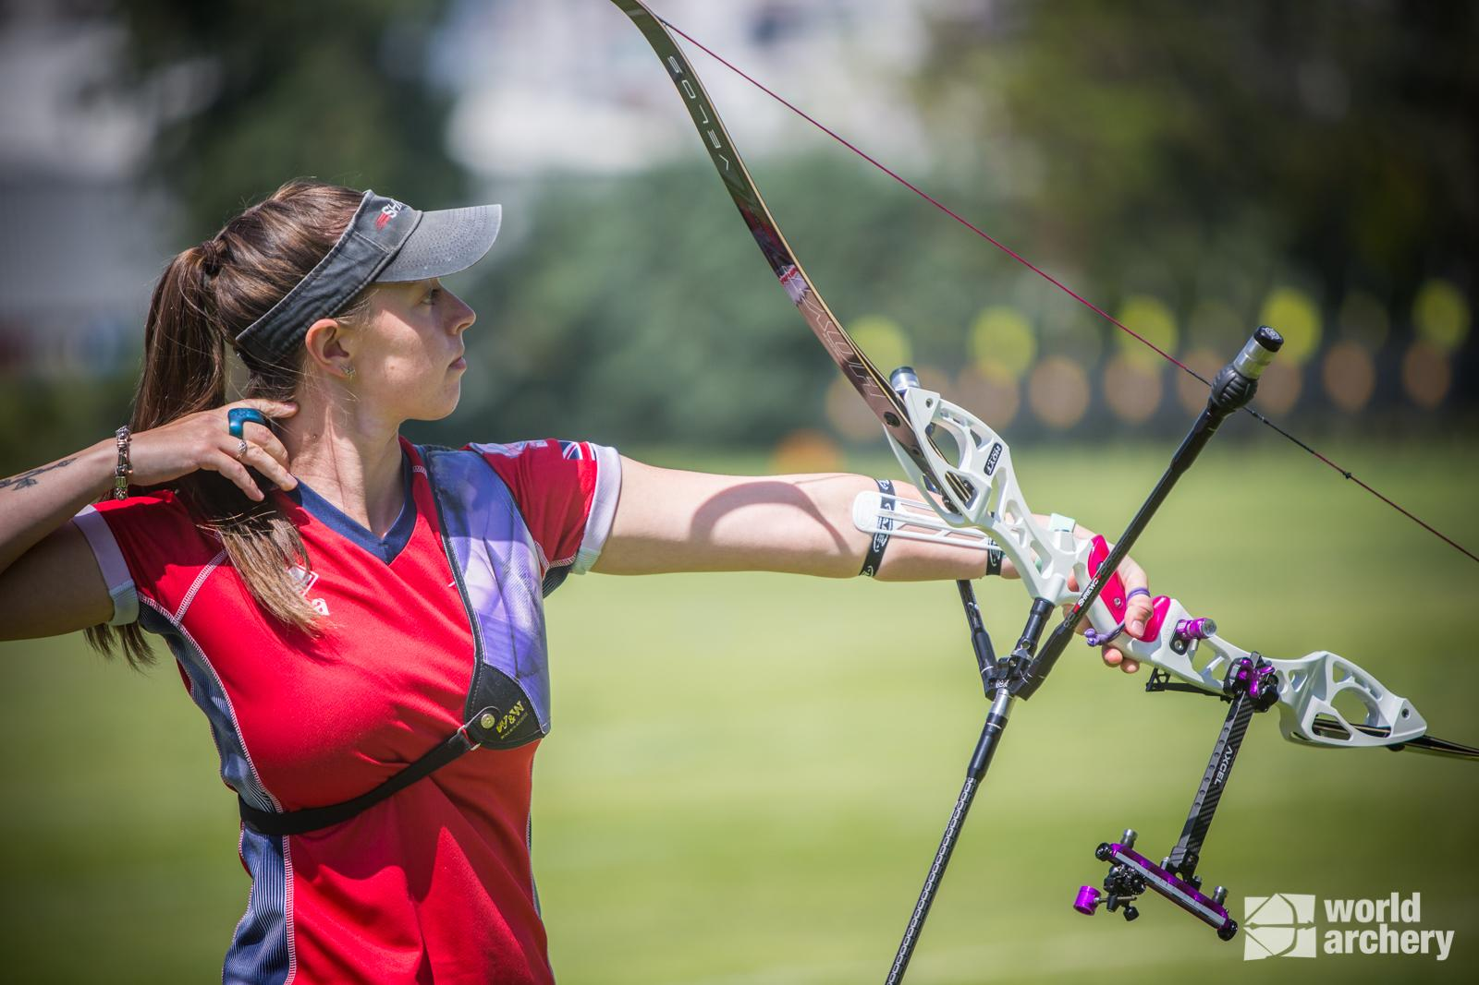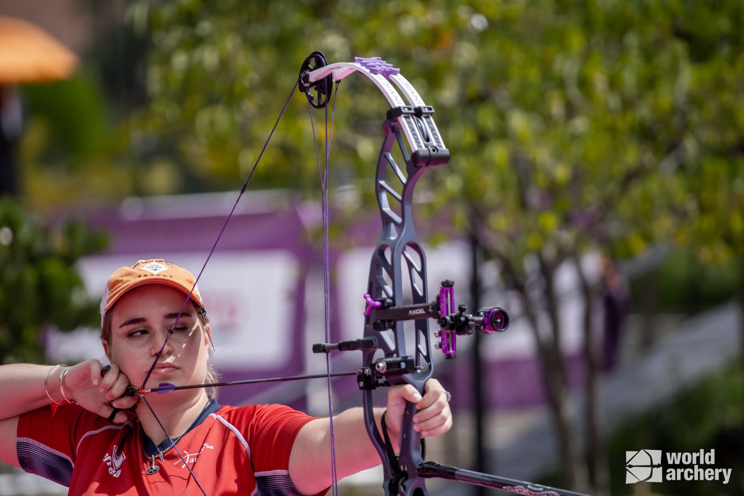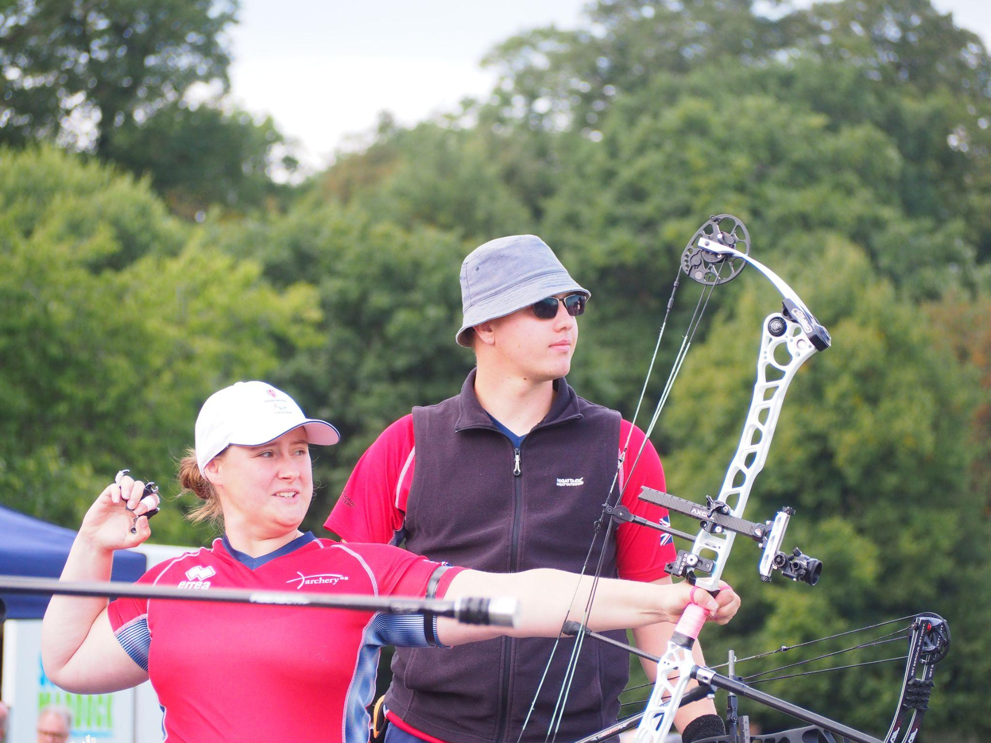
Left to right: Bryony Pitman (Photo credit: World Archery), Ella Gibson (Photo credit: World Archery), Phoebe Paterson Pine (Photo credit: Archery GB)
27 January 2023: Bryony Pitman has secured the world number one spot in Women’s Recurve archery - making her the first British recurve archer in the World Cup-era to hold the top spot in world rankings. With Ella Gibson retaining the world number one title for Women’s Compound archery and Paralympian Phoebe Paterson Pine holding top position in Compound Women Open, GB’s female archers are trailblazing the way.
This fantastic new achievement for Pitman herself and the Great British team is true testament to the dedication of the performance archers, as well as the amazing young talent it holds.
Shoreham’s Bryony Pitman (aged 25) - World Number One Women’s Recurve Archery
This week’s release of the Sanlida World Archery Ranking saw Olympic archer Bryony Pitman claim the top spot in Women’s Recurve archery - an accolade well-deserved following a successful 2022 year of competitions and challenges.
Competing in a host of tournaments, Pitman picked up a tremendous number of medals, including one individual gold, one team gold and one team silver at the Antalya Hyundai World Cup 2022 in Turkey (April 2022).
Pitman won silver in the Recurve Women’s Team event, alongside Jaspreet Sagoo and Penny Healey, at the Medellin 2022 Hyundai Archery World Cup Stage Four (July 2022), Individual Recurve Women’s silver at the World Archery Field Championships in Yankton (October 2022) and silver at the World Games in USA (July 2022).
Pitman made her Olympic debut at the Tokyo 2020 Games, finishing ninth both individually and in the women’s team. In 2019, she was part of the bronze winning team at the World Archery Championships and won gold as part of the Women’s Recurve team at the European Games, Minsk.
Phoebe Paterson Pine MBE (aged 25) - World Number One in Compound Women Open
Paralympian Phoebe Paterson Pine claimed her number one spot in the Compound Women Open category in July 2022, following exceptional successes at the first leg of the Para Archery European Cup in Nove Mesto, Czech Republic.

In Nove Mesto, she secured Individual Compound Women Open gold, gold in the Compound Women Open Team event alongside Jessica Stretton and bronze in Compound Open Mixed Team competition with Jamie Harris. In August, her success continued with a gold win in the Compound Women Open event and a silver in Compound Women Open Doubles, alongside Jessica Stretton.

She is a junior indoor and outdoor national champion and holds multiple National, European and World records - breaking five UK, European and World records over five days in 2022!

During her Paralympic debut in Tokyo, she won gold in the Compound Women Open and while she has been a member of the Archery GB para squad for some years, she has also now been named as a member of the Archery GB national Compound squad.

She has spina bifida and first tried archery on a family holiday, enjoying it so much she joined her local club. A student at Worcester University, studying sports coaching science, Paterson Pine moved to Telford in 2019 from her family home in Cirencester, in the Cotswolds.

Ella Gibson (aged 22) - World Number One Women’s Compound Archery
Following her tremendous success at the 2022 World Games in Birmingham USA in July, Gloucestershire’s Ella Gibson took the number one spot in Women’s Compound Open archery – beating her 2022 goal of making the top ten list. At the event, Gibson took gold, beating the then world number one Sara Lopez – who had spent a record 1,445 days in the top spot.
Gibson won multiple medals at June’s 2022 Hyundai Archery World Cup Stage 3 competition, including Individual Women’s Compound gold, silver in the Compound Women’s Team event (with Layla Annison and Liz Foster) and Compound Mixed Team bronze (with Adam Carpenter).
June’s European Championships in Munich saw Gibson and her teammates, Izzy Carpenter and Paralympian Jess Stretton, put the inclusivity of archery into practice, winning gold in the Women’s Compound Team competition.
Competing internationally since 2018, Gibson has broken a number of records - including the European record whilst competing at the Hyundai Archery World Cup Stage 3 in Paris. Additionally, her 2022 success saw her secure gold at the stage 3 in Paris and silver at the Tlaxcala 2022 Hyundai Archery World Cup Final.
Gibson first tried archery in 2014 when coaches from Xperience archery came to her secondary school. The six-week after-school taster session led Gibson to a beginners’ course with Deer Park Archers and she joined the club in June 2015.

Gibson’s family own and run Dolcetti Ice Cream, in Cirencester, recently moving to bigger premises, which includes a 25-metre indoor range so Gibson can continue to shoot, whatever the weather.

Further inspiring talent in British women’s archery
Pitman, Paterson Pine and Gibson are not the only leading females in archery though - the Great British squad is filled with young talent.

In September, Yorkshire’s Isabelle Carpenter (aged 24) went viral on TikTok following a video of her hitting three Xs (centre point of target) all touching one another and all shot consecutively in the same end, at the National Tour Finals in Nottingham. Her medal success includes two gold medals at the European Championships in Munich - Individual Compound Women gold and Women’s Compound Team gold alongside teammates Ella Gibson and Jessica Stretton. At July’s Medellin 2022 Hyundai Archery World Cup Stage Four, Izzy once again took team gold, this time alongside Liz Foster and Ella Gibson.

Penny Healey (aged 17) also has a wonderfully successful year, winning gold in the women’s recurve team final at April’s Antalya Hyundai World Cup 2022 in Turkey, alongside Bryony Pitman and Jaspreet Sagoo. She was the Indoor World Series Recurve Women Champion 2022, secured 4th place individually at the Paris World Cup 2022, and was the 2021 National Tour Final Recurve Women’s champion. Alongside this, Healey has shot the European junior, national senior and junior WA720 record.
- ENDS -
Media Contacts: White Tiger PR - Archery@whitetigerpr.com
Leanne Barton / Leanne.barton@whitetigerpr.com / 07568 925069
Kimberley Powles / kimberley.powles@whitetigerpr.com / 07966 867827

About Archery GB
Archery GB is the British body for all forms of archery in the UK, an inclusive sport which lends itself to all spectrums of the population - regardless of age, disability or gender. With over 820 clubs and over 34,400 members, Archery GB is affiliated to World Archery, British Olympic Association & British Paralympic Association. More information www.archerygb.org. Beginners can visit www.startarchery.co.uk to find beginners’ courses and clubs near them and to learn more about the sport.

