WORLD CHAMPIONSHIP SUCCESSES SECURE GB ARCHERS VITAL PARALYMPIC QUOTA SPOTS AS COUNTDOWN TO PARIS BEGINS
- Four medals were won at the Championship
- Phoebe Paterson Pine and Jodie Grinham won a gold medal in the women's compound open category
- Steve Prowse won a gold medal in the visually impaired 2/3 category
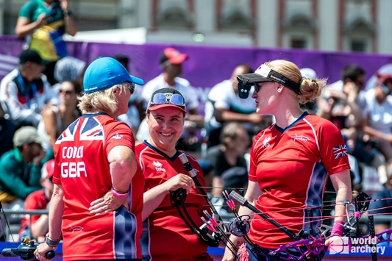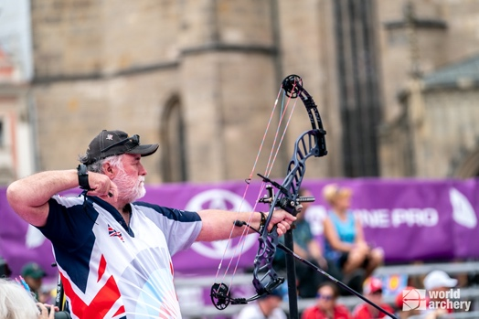
(Photos left to right: Phoebe Paterson Pine and Jodie Grinham compete in their final. Steve Prowse shooting to victory. (Credit: World Archery).
26 July 2023: Archery GB is celebrating the successes of several of its athletes at the World Para Championships which was held in Pilsen, Czech Republic. Their success also secured vital Paris 2024 Paralympic quota spots for Great Britain, as the one-year countdown to the 2024 games begins, today.
In the visually impaired 2/3 category, archers from Great Britain monopolised the final shoot-offs fielding three of the final four athletes vying for the much-desired medals.
The fight for gold however was between, Stourbridge based Steve Prowse and Italy’s Daniele Piran. Steve, a three-time winner of this title previously, drew on all of his expertise to battle through an incredibly close match, with both archers shooting some amazing rounds to eventually secure his fourth World Para Championship title and the gold medal with a 6-2 victory.
Speaking of his impressive win Steve said: "This is my fourth World Championship gold medal, and everyone is so special for its own reason. The range of archers, from a growing number of countries participating, is therefore now making the category far more competitive, which can only be a good thing for the future of VI archery."
In the previous match, Nick Thomas from Talysarn, Wales mastered an impressive 6-0 victory over fellow Brit Phil Tranter to win the bronze medal, a medal made even more impressive by the fact that Nick's preparations for the championships were heavily hampered by a huge medical setback in May.
Following his bronze medal win, Nick said: "Winning the bronze medal feels like a huge achievement. I suffered a stroke in late May and was scared that would be the end of my Championship hopes, but with hard work and determination I was able to achieve a fantastic result."
Golden glory was also celebrated over in the compound category, as Phoebe Paterson Pine and Jodie Grinham successfully shot to the gold medal in the women’s open doubles. Facing Brazil in the final, the pair came from behind to finish their final with an almost perfect points finish in the final round of shooting to secure the title 152-145.
Speaking of the history of their partnership, Jodie said: "We've shot together for years like when it was a three-person team, even when it went to doubles, we've shot together. We won gold back in Czech Republic but the one thing we'd never done was got World Champion, so we've ticked that box finally."
Telford-based athlete Phoebe added: "I think for me personally, having gone out and got Paralympic Champion, European Champion and now World Champion I feel like I've got the set. So, I feel like I exceeded my expectations of what I wanted to come out here and do."
In the final match of the compound category, Nathan Macqueen competed for the compound men’s open title against Italy’s Matteo Bonacina. Both men were tied after the first two ends, setting up a nail-biting end to the match. With Nathan battling valiantly and pushing the Italian to shoot at his very best right to the end, Nathan narrowly missed the gold medal by 2 points, with the final score being 141-139 resulting in a silver World Para Championships medal for the Brit.
Shortly after the final, Nathan said: "It means the world to me to finally bring home a Worlds medal. I got myself into a really good spot for the Worlds in 2022 and unfortunately missed it due to catching covid two days before flying. So, this is redemption for me. I was just trying to take it an arrow at a time and not think too much about anything else other than the next shot."
For more information on Archery GB and its performance teams, please visit archerygb.org.
-Ends-
Notes to Editors:

The World Championships took place in Pilsen Czech Republic between 17 July - 23 July.

Images can be downloaded here.

The team’s success at this competition has secured Team GB the following quota spots for the 2024 Paralympic Games in Paris:
- 2 athletes in the compound women open category
- 1 athlete in the compound men open category

Athlete Profiles:

Steve Prowse: Steve shoots in the vi 2/3 category and is now a four-time World and two-time European Para Archery champion. He is based in Stourbridge, in the West Midlands and first began shooting in 1999.

Nick Thomas: Nick is currently ranked 5th in the world in the VI 2/3 category and is an international medal-winning VI archer from North Wales. Nick won bronze in both the 2019 World Para Archery Championships and in the 2018 European Para Archery Championships. He holds a degree in sports science and has enjoyed a wealth of success across visually impaired sports.

Nathan Macqueen: Macqueen is an all-round sportsman who played rugby for Glasgow Warriors at under 18 level before he was involved in a serious motorbike accident when he was 17 years old. Before his accident, Macqueen was part of Scotland's archery team. After he was injured, he took up powerlifting and wheelchair basketball. But following a shoulder injury, he switched back to archery, making his international debut just months before Rio 2016, where he finished a highly respectable ninth.
The 29-year-old from Dumfries in Scotland has also won multiple medals at European and World level. He was part of the gold-winning compound open mixed team at the Rome 2022 European Para Archery Championships along with Jessica Stretton. He also won bronze as part of the compound open men's team at the same event with Jamie Harris.

Jodie Grinham: Jodie first got involved in archery in 2008 when she saw her dad shooting at their local club and decided she would like to give the sport a go. After going through the Archery GB National Talent Development Programme, Jodie was selected to join the GB squad in 2014 and started competing internationally.
Jodie was selected to make her Paralympic debut at Rio 2016 and she made it in style, winning silver in the mixed team compound open alongside Beijing gold medallist John Stubbs.
In 2019, Jodie won team silver at the World Championships in Hertogenbosch, Netherlands.

Phoebe Paterson Pine: Phoebe is the current Paralympic champion, the 2022 European Para champion and world number 3. She won gold at her Games debut in Tokyo winning the Compound Women Open, and while she has been a member of the Archery GB para squad for some years, she has also now been named as a member of the Archery GB national compound squad. She has spina bifida and first tried archery on a family holiday, enjoying it so much she joined her local club. Phoebe is a student at Worcester University, studying sports coaching science.

She holds multiple National, European and World records, breaking five UK, European and World records over five days in 2022! She was appointed an MBE for her services to archery in the New Years Honours list 2022.

Media Contacts – Spider PR
Rebekah Smith / rebekah.smith@wearespider.com / 07840 104801

About Archery GB
Archery GB is the British body for all forms of archery in the UK, an inclusive sport which lends itself to all spectrums of the population - regardless of age, disability or gender. With over 820 clubs and over 34,400 members, Archery GB is affiliated to World Archery, British Olympic Association & British Paralympic Association. More information www.archerygb.org. Beginners can visit www.startarchery.co.uk to find beginners’ courses and clubs near them and to learn more about the sport.

