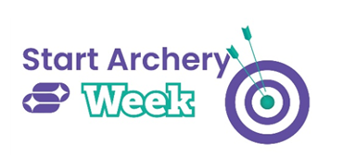

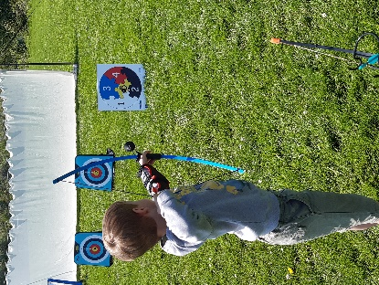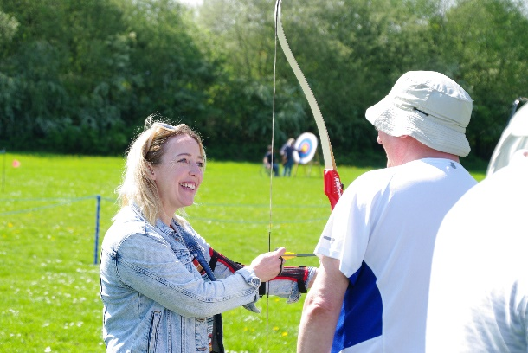
Photo credit: Archery GB

DRAW BACK YOUR BOWS FOR START ARCHERY WEEK
Archery GB are welcoming all to have a shot at archery
26 April 2024 – Since it began, Start Archery Week, which this year will take place between 4-12 May, has introduced over 70,000 people to archery thanks to archery clubs and activity providers taking part in this nationwide week dedicated to welcoming more people to the sport.
Now in its 12th year, with Kinetic and Avalon Archery on board as partners for 2024, it will see archery clubs across the country open their doors to potential archers, giving people of all ages and abilities the chance to try archery for the first time. There will also be opportunity for participants and volunteers to win a host of prizes from Kinetic and Avalon Archery.
One of the most accessible sports around, it’s fun and inclusive and perfect for anyone wanting to try something new, either on their own or with family and friends. Whether you’re a complete novice or have never thought about picking up a bow and arrow before, this is a perfect chance to give it a go. It’s also the ideal opportunity to discover the joy of this inclusive sport ahead of the Paris 2024 Olympic and Paralympic Games.
Archery clubs across the country are inviting adults and children alike to take part throughout Start Archery Week. Between Saturday 4 to Sunday 12 May, clubs will be hosting their very own events, inviting locals from nearby areas to give archery a shot.
Participants will not only be able to have a go at the sport, but they will also be able to spend time with coaches who will guide them through the basics, ensuring a safe and enjoyable introduction to archery. In addition, visitors will be able to sign up for a beginner’s course to kickstart their archery journey.
“For me archery offers both physical and mental benefits – there’s no other sport quite like it. You are so focused on what your body is doing that it’s like meditation,” says Jamie Harris, member of the Archery GB Paralympic Squad, who took up the sport at 14 years old. “Start Archery Week offers a great opportunity for people to have a go and appreciate how accessible the sport is – for everyone. It would be great to see more people taking up the sport and playing it regularly and getting to love it like I do."
Nathan Macqueen, who is also a member of the Archery GB Paralympic Squad and hoping to retain his world number one spot this year, started archery as a child. He says: “Originally archery was something my Dad and I used to do to spend time with each other, then I took up the sport again after I had a motorcycle accident. Archery is a great social sport that anyone can enjoy with a level playing field. It offers great mental health benefits too – as you focus on shooting the arrows it gives you a break from reality.”
This year’s events are shining a light on the mental health benefits of archery and how the sport can help people’s minds as well as their bodies. It can support increased mindfulness, enhance mental and emotional wellbeing, reduce stress and boost confidence as well as develop strength and fitness.
To find out more about Start Archery Week visit https://startarchery.co.uk/, to search for events taking place near you visit https://startarchery.co.uk/start-my-journey/find-an-experience or to find out more about how you can be in with a chance of winning one of the prizes from Kinetic and Avalon Archery visit https://archerygb.org/news/kinetic-and-avalon-archery-announced-as-start-archery-week-premium-partners

-Ends-
Notes to Editors:
Hi-res images will be available to download during the week here. Please credit Archery GB: https://archerygb.smugmug.com/Start-Archery-Week/SAW-2024
Media Contacts
Bethan Simkins or Laura Wilson at archerygb@targetgroup.co.uk or call 01242 633100.
To find an event taking place near you please use our experience finder here: https://startarchery.co.uk/start-my-journey/find-an-experience
About Archery GB
Archery GB is the British body for all forms of archery in the UK, an inclusive sport which lends itself to all spectrums of the population - regardless of age, disability or gender. With over 800 clubs and more than 38,300 members, Archery GB is affiliated to World Archery, the British Olympic Association and the British Paralympic Association. More information: www.archerygb.org Beginners can visit www.startarchery.co.uk to find beginners’ courses and clubs near them and to learn more about the sport.

