GB ARCHERS SHOOT TO SUCCESS AT 2023 WORLD CUP
- 18-year-old Penny Healey wins gold in women’s recurve
- Shropshire star shoots to the top of Recurve World Number One
- Compound World Number One Ella Gibson finishes 4th
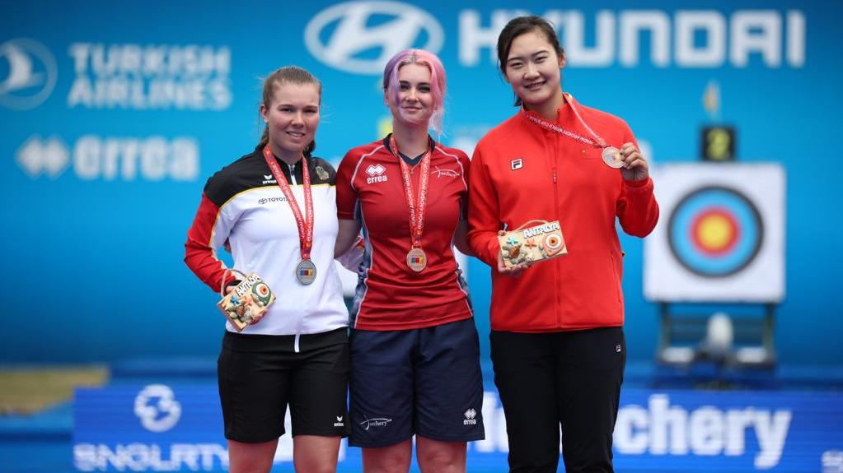
(Photos left to right: Penny Healey made history taking Gold in the Recurve Women category (Credit Izzy Carpenter/World Archery).
24 April 2023: Great Britain's Penny Healey has secured a place in the Archery World Cup finals following an awe-inspiring gold medal win at the Antalya 2023 Hyundai Archery World Cup Stage 1.
Bringing added success for Healey, her gold medal win also means she is now ranked World Number 1 in the Recurve Women category.
The Shropshire archer shot to her first individual gold World Cup medal following a sensational week of archery. Healey dominated her final against Germany’s Elina Idensen and never looked in doubt to take the title completing an impressive 6-0 victory.
The win sees the teenager emulate the success of her British teammate Bryony Pitman, who won gold at the same event in 2022.
On her win in Antalya, Healey said, “It feels amazing, after that last arrow I was like ‘did it do it or not’ but I can’t believe it’s happened. It feels unreal.”
“I will be honest; I was so nervous. My legs and arms were shaking, but having [coach] Nicky Hunt in the box singing and dancing with me helped a lot. I am glad to follow in Bryony’s footsteps.”
Gloucestershire’s Ella Gibson, current world number one in the Women’s Compound category, also made a notably strong start to her World Cup campaign. Making it through to the individual event semi-finals she was beaten by the eventual gold medalist, India’s Jyothi Surekha Vennam and will be looking to improve on this when the athletes head to Stage 2 in Shanghai next month.
Held annually, the revered Hyundai Archery World Cup brings together the best archers from across the globe to compete both individually and as teams throughout its four stages, with archers seeking to earn a place at September’s World Cup final in Mexico.
For more information on Archery GB and its performance teams, please visit archerygb.org
-Ends-
Notes to Editors:

The Hyundai Archery World Cup is archery's annual elite international competition. Consisting of four stages and a grand finale to which only the best athletes in each of the four international competition categories (Male/Female Compound and Male/Female Recurve) are invited.

Player Profiles:

Penny Healey: Penny is the youngest on the squad, at just 18 years old. She started archery when she was 9, after watching the Disney movie “Brave”. It inspired her to have a go at archery, as it looked enjoyable and she used to do horse riding. Penny did her beginners course at Audco Archers, in Shropshire. Penny’s proudest achievement to date is winning the Indoor World Series Finals in 2022 in Las Vegas. Along with shooting the European junior, national senior and junior WA720 record.

Ella Gibson: Current World Number 1 Ella first tried archery in October 2014 when some coaches from Xperience archery came to her secondary school. They put on a six-week taster session after school and that led to a beginners’ course with Deer Park Archers and she joined the club in June 2015. Ella has competed internationally since 2018, winning a silver at the European Outdoor Championships, bronze at the Lancaster Classic and team medals on the World stage.

In February, 2022, her first big win individually on the international stage came when she took gold and the compound women European Indoor Champion title in Slovenia. In the same year she won the National Tour Final, individual gold at stages 1, 3 and 4 of the World Cup and silver in the World Cup Final. Ella won gold at the Birmingham 2022 World Games. As part of the women’s team, she won gold at the European Championships and silver at World Cup stages 3 and 4. She won bronze as part of the mixed team at the third stage of the World Cup.

Archery GB results for Antalya 2023 Hyundai Archery World Cup Stage 1:

Compound Women:
4th Ella Gibson
33rd - Grace Chappell, Izzy Carpenter
Compound Women’s Team - 5th

Recurve Women:
1st - Penny Healey
17th - Bryony Pitman
65th - Jaspreet Sagoo, Louisa Piper
Recurve Women’s Team - 9th

Recurve Men:
17th – Alex Wise, Tom Hall
33rd - James Woodgate, Monty Orton
Recurve Men's Team - 17th

Recurve Mixed Team – 9th

Media Contacts - White Tiger PR - Archery@whitetigerpr.com
Leanne Barton / Leanne.barton@whitetigerpr.com / 07568 925069
Rebekah Smith / rebekah.smith@whitetigerpr.com / 07840 104801

Hi-res images can be downloaded here

About Archery GB
Archery GB is the British body for all forms of archery in the UK, an inclusive sport which lends itself to all spectrums of the population - regardless of age, disability or gender. With over 820 clubs and over 34,400 members, Archery GB is affiliated to World Archery, British Olympic Association & British Paralympic Association. More information www.archerygb.org. Beginners can visit www.startarchery.co.uk to find beginners’ courses and clubs near them and to learn more about the sport.

