ARCHERY GB HAILS SUCCESS OF YOUNG ATHLETES AT EUROPEAN YOUTH ARCHERY CHAMPIONSHIPS
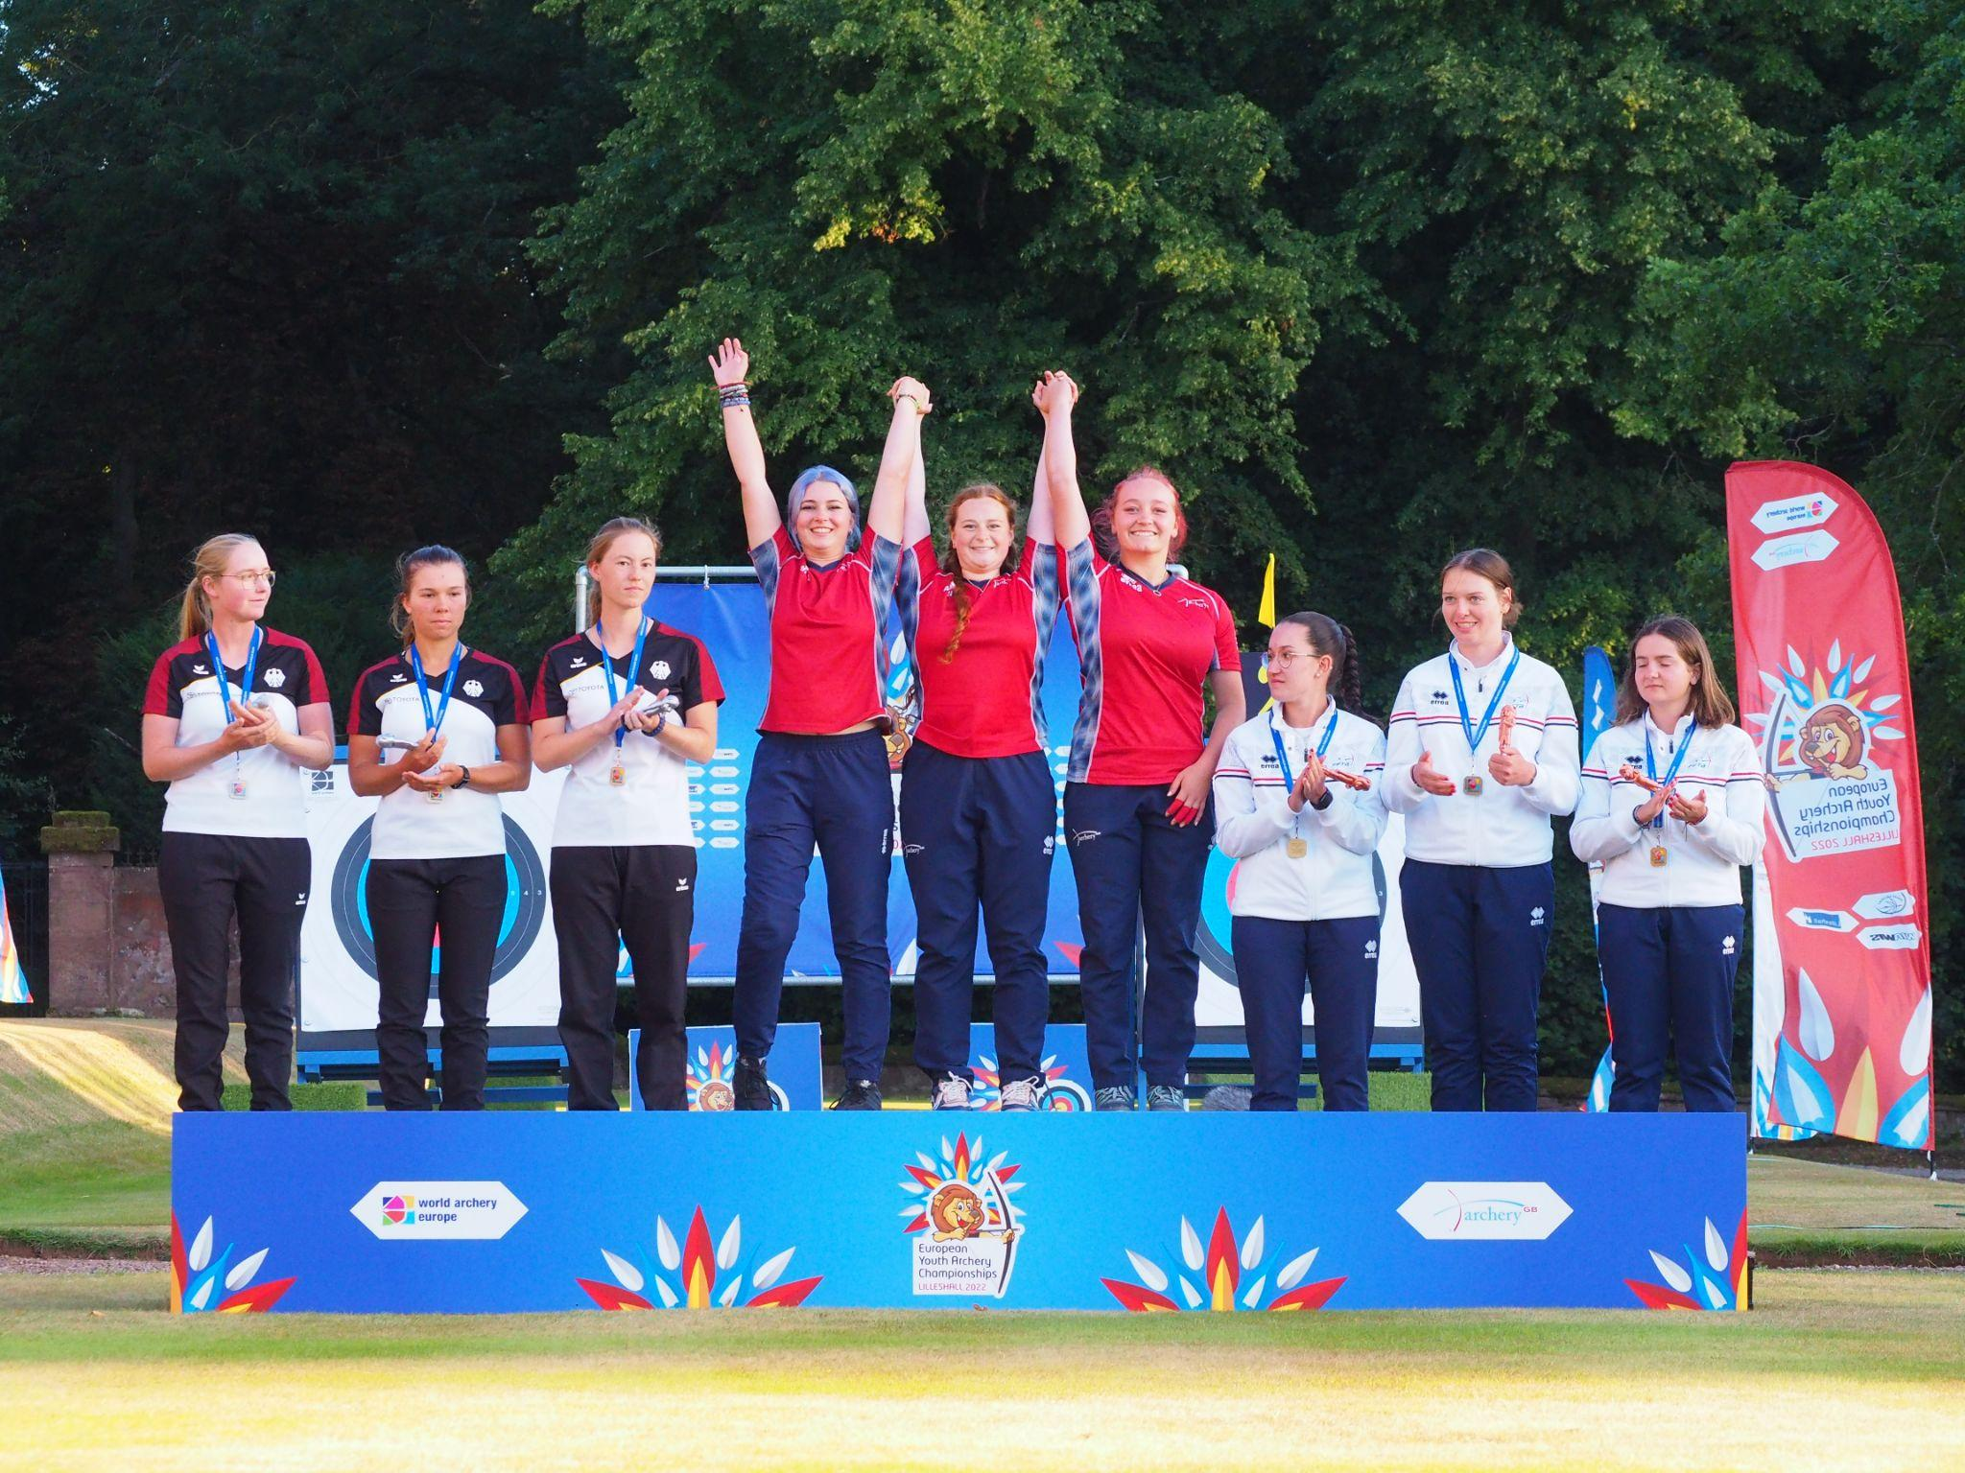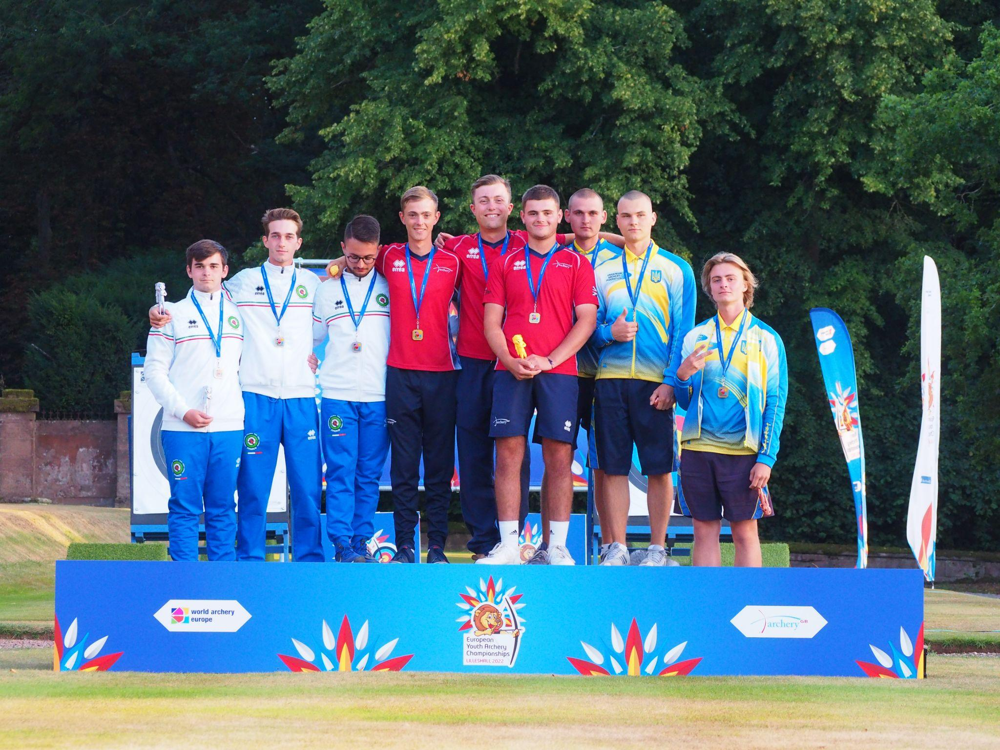
- Young GB archers secure seven medals in team and individual events
- Four golds amongst medal wins for GB
- Squad of 24 GB archers took part in competition at Lilleshall
- More than 300 athletes from 36 countries competed over six days
22 August 2022: Archery GB has hailed the success of its young athletes following their participation in a major competition on home soil.
A squad of 24 archers aged between 14 and 20 shot alongside more than 300 athletes from 36 countries in the European Youth Archery Championships at Lilleshall National Sports Centre.
The competition started on August 15, with team medals awarded on Friday August 19 and individual finals held on Saturday August 20.
Under 21 Recurve archers secure three gold medals
It was a successful weekend for the U21 Recurve team members, with three gold medals secured across team and individual events.
Charlie Medhurst, Monty Orton, and James Woodgate became European team champions after winning gold in Friday’s Recurve Under 21 Men’s Team finals.
Megan Costall, Penny Healey and Louisa Piper secured the top spot in the Recurve Under 21 Women’s Team events, taking the European title.
Monty Orton is now reigning European Recurve Under 21 Men’s Champion having won Individual Gold.
The Recurve U21 Mixed Team of Penny Healey and James Woodgate also reached the bronze medal match, securing fourth place in the category for GB.
Silver and Bronze for the Compound Under 21 athletes
In the Compound Under 21 Women’s Team competition, Chloe A’Bear, Layla Annison and Grace Chappell secured silver for Great Britain.
On Saturday, Grace Chappell continued her medal winning performance, securing bronze in the Compound Under 21 Women’s individual events.
Compound Under 18 women secure gold and silver for GB
Taking to the field on Friday, Hallie Boulton, Sinead Byrne and Patience Wood secured silver in the Compound Under 18 Women’s Team competition.
Continuing GB’s success, Hallie Boulton also took individual gold and the European Champion title in the Compound Under 18 Women final.
The Compound U18 Men’s Team of Oscar Orford, Jay Saunderson and Finlay Clark successfully reached the bronze medal match, finishing fourth overall.
Archery GB celebrates the immense talent of GB’s young archers
The European Youth Archery Championships was the perfect opportunity for young archers aged 20 and under to make their name on home soil and showcase the immense talent within the team, with the encouragement of local support.
Commenting on the success of the team, Archery GB’s Compound Programme Manager Jon Nott said: “We’re so proud of how all our young athletes have risen to the challenge of competing in this prestigious event this week.
“We’ve had some brilliant successes thanks to their hard work and dedication. It really shows that we have a wealth of young talent coming through who will be challenging for places in the top world events in the years to come.”
Neil Armitage, CEO at Archery GB, said: “It has been inspiring to watch these young archers from all over Europe taking part in this inclusive, diverse and exciting event.
“We’d like to thank all the staff and volunteers who have worked so hard to make this tournament a great success and to raise the profile of this wonderful sport.”
Great Britain’s archers are continuing a tremendous year of success, with gold, silver and bronze medals being won at multiple events worldwide including the European Championships in Munich, World Games in the USA, Para Archery European Cup in Nove Mesto, Czech Republic, the Hyundai Archery World Cup in Medellin, Colombia, and the European Youth Cup in Bucharest.
The European Youth Archery Championships is held on behalf of World Archery Europe every two years. The 2018 competition took place in Patras, Greece and the planned 2020 event at Lilleshall was cancelled due to the Covid-19 Pandemic.
-ends-
Notes to Editors -
Video footage is available on request.
Hi-res images are available from the dropbox at (please credit Archery GB):
https://www.dropbox.com/sh/70lw2vhl0fmd1a1/AACuy3TF6ARo5PWGV2_9K8Lba?dl=0
More hi-res images are available from Archery GB’s Smug Mug (please credit Archery GB) at https://archerygb.smugmug.com/European-Youth-Championships-2022

Team biographies
Compound men U21

Lewis Haslam - Age 19 - Heage, Derbyshire
Lewis is currently 11th UK Senior ranked, European Youth Championship team gold 2018 Greece. 2021 Archery GB Youth Festival compound youth man champion. He uses a Mybo Revolution 40 bow and his archery club is Derwent Bowmen. He’s been shooting for 9 and a half years and biggest achievement to date is winning the European Youth Championships cadet team event in 2018 in Greece. His favourite place to shoot has been Rovereto, Italy, for the European Youth Cup 2018.

Dillon Crow - Age 20 - South Shields
Dillion is currently 13th UK senior ranked, Archery GB 2022 National Tour stage 2 winner. He uses Mathews TRX 40 bow and his archery club is Cleadon Archers. He has been shooting for 10 years this year and his biggest achievement is making the Great Britain junior team. His favourite place to shoot has been his home club states ‘it will always be my favourite outdoor venue’. His favourite indoor venue would be Nimes.

Thomas Lane - Age 17 - Diseworth, Derbeyshire
Thomas is 2nd Junior UK ranked and currently 17th UK senior ranked, 2021 Archery GB Youth Festival compound youth man silver. Junior indoor National Championships 2021 compound junior men bronze. He uses a PSE citation bow and his archery club is Wilford Bowmen. He’s been shooting for 6 years and his biggest achievement is representing Great Britain at the World Youth Championships in Poland in 2021. His favourite place to shoot is Wroclaw, Poland.

Compound women U21:

Layla Annison - Age 19 - Norwich, Norfolk
Layla is currently 2nd UK Senior ranked, 20th European ranked, 38th world ranked. 2021 Senior World Championship 5th place compound women team, European Youth Championship individual gold medal Greece 2018, Antalya World Cup team bronze 2019, and Paris World Cup 2021 team silver. She uses a Mybo Revolution 40 bow and is a member of the Wymondham Archers club. She’s been shooting for 9 years and biggest achievement to date is winning the European title and winning medals at a senior level internationally. Her favourite place to shoot has been Antalya.

Grace Chappell - Age 20 - Cambridge, Gloucestershire
Grace is currently 11th UK Senior ranked, European Youth Cup individual gold cadet women Slovenia 2019. 2021 Archery GB Youth Festival compound junior women silver.
She uses a Hoyt Invicta bow and is a member of the Deer Park Archers and Canford Magna Bowman. She has been shooting for 6 and a half years and biggest achievement is winning the European Cup in Slovenia as a Cadet in 2019, as well as coming 6th at the National Tour Final in 2021. Her favourite place to shoot is at her home clubs where she feels most relaxed and also the new Barnsley Archery Club field.

Chloe A’Bear - Age 17 - Cirencester, Gloucestershire
Chloe is a 1st Junior UK ranked and currently 8th UK Senior ranked. 2021 Archery GB Youth Festival compound cadet women champion. Indoor National Championship 2021 compound women 5th place. She uses a Hoyt Invicta 37 bow and is a member of the Deer Park Archers. She has been shooting for 11 years, the first 4 and a half years was spent shooting a barebow before switching to compound. Her biggest achievement is being selected to shoot for Great Britain at the World Youth Championships where she finished in 7th. Also becoming Junior National Champion numerous times, and finishing 3rd overall at the UK Senior Masters. Her favourite place to shoot is at Surrey which is usually for the national tour.

Compound women U18:

Hallie Boulton - Age 17 - Wigan, Lancashire
Hallie is 2nd Junior UK ranked and currently 7th UK Senior ranked. 2021 Archery GB Youth Festival compound cadet women silver. Junior Indoor National Championship 2021 compound junior women champion. She uses a Hoyt Invicta bow and is a member of the Spinners Mill Archers. She has been shooting for 6 years. Her biggest achievement is getting into an individual match at the Youth World Championships, especially since it was her first international competition and went there with no expectations. Her favourite place to shoot: Bebington Archery Club.

Sinead Byrne - Age 17 - Banbridge, Co. Down
Sinead is currently 31st UK Senior ranked. European Youth Cup bronze individual cadet women in Bucharest 2021. Junior Indoor National Championships 2021 compound junior women silver.
She uses a Hoyt Invicta bow and is a member of the Ballyvally Archers Banbridge. She has been shooting for 9 years. Her biggest achievement is making the podium at the European Youth Cup in Romania last year, taking home an individual bronze medal, and also taking home the bronze in the teams at the European Field Championships last year in Croatia. Her favourite place to shoot is Las Vegas for indoors and Romania for outdoors.

Patience Wood - Age 15 - Prenton, Merseyside
Patience is 3rd Junior UK ranked and Currently 22nd UK Senior ranked. European Youth Cup bronze cadet team Bucharest 2021. 2021 Archery GB Youth Festival compound cadet women bronze. Junior Indoor National Championships 2021 compound junior women bronze. She uses a Hoyt Invicta 40” bow and is a member of the Bebington Archers, Cheshire. She has been shooting for 6 years. Her biggest achievement is winning a team bronze medal in Romania in 2021 with Bella and Beth. Her favourite place to shoot is the Youth Festival, Lilleshall.

Compound U18 men:

Oscar Orford - Age 17 - Thurlby, Lincolnshire
Oscar is 3rd Junior UK ranked and currently 35th UK Senior ranked. 2022 international debut at the Indoor European Championships in Slovenia. Junior Indoor National Championships 2021 compound junior men champion. He uses the Mybo Revolution 37 bow and is a member of the Silverspoon Bowmen. He has been shooting for 4 years. His biggest achievement is making it to Slovenia for the European Indoor Championships and his favourite place to shoot is at Meriden Archery Club.

Jay Saunderson - Age 16 - Larne, Co. Antrim
Jay won a European Youth Cup bronze cadet men’s team medal in Bucharest 2021. Junior National Indoor Championships 2021 compound junior men 6th place. He uses the Matthews TRX 38 bow and has been shooting for 5 years. He is a member of Spider Archery. His biggest achievement is getting a silver medal at the European Youth Cup. His favourite place to shoot has been in Bucharest, Romania - at the European Youth Cup.

Finlay Clark - Age 16 - Kirkella, East Yorkshire
Finlay is a 1st Junior UK ranked and currently 62nd UK Senior ranked. European Youth Cup bronze individual cadet men, and silver cadet men team medal in Bucharest 2021. He uses a PSE Supra RTX bow and is a member of the York Archers Society & Wyke Archers. He has been shooting for 6 years. His biggest achievement is representing Great Britain at the European Youth Cup 2021 in Romania and winning two medals. His favourite place to shoot is at Lilleshall.

Recurve U21 men:

James Woodgate - Age 20 - Shepperton, Middlesex (Studying at University of Warwick)
James is currently 15th UK Senior ranked, 53rd European ranked. Tokyo 2020 Olympian, AGB National Indoor recurve man 4th place, 9th place World Youth Championships Poland 2021. He uses a Wiawis Meta DX and MXT-10 limbs bow and is a member of the Woking Archery Club. He has been shooting for 12 years. His biggest achievement is coming 5th place in teams at Tokyo 2020, and his favourite place to shoot is at the Meriden Archery Club.

Monty Orton - Age 18 - Tamworth, Staffordshire
Monty is currently 7th UK Senior ranked. AGB Youth Festival 2021 recurve junior men champion, AGB Back to Back 2021 top 6. He uses a Fivics Argon-x bow and is a member of the Meriden Archery Club. He has been shooting for 5 years. His biggest achievement is being selected to shoot at the European Youth Cup 2021 in Bucharest, as it was his first time shooting for GBR. His favourite place to shoot is Meriden Archery Club.

Charlie Medhurst - Age 17 - Northfield, West Midlands
Charlie is a 3rd UK Junior ranked and currently 14th UK Senior ranked. AGB Youth Festival 2021 recurve cadet men champion, Junior National Outdoor Championships 2021 Bristol 1 Men’s recurve silver medal. He uses a Hoyt Xceed bow and is a member of the Redhill Archers. He has been shooting for 10 years. His biggest achievement is winning the Youth Festival individually. His favourite place to shoot at is the Lilleshall Orangery.

Recurve U21 women:

Penny Healey – Age 17 - Shifnal, Shropshire
Penny is currently 4th UK Senior ranked, 19th European ranked, and 31st World ranked. Indoor World Series recurve women Champion 2022, 4th place individually at the Paris World Cup 2022, World Cup Antalya 2022 team gold medal, and 2021 National Tour Final recurve women’s champion. She uses a Wiawis Archery AFT-X riser and NS-Graphene limbs bow and has been shooting for 8 years. Her biggest achievements to date are winning the indoor World Series final, coming 4th at the third World Cup this year, and getting team gold at the Antalya World Cup. Her favourite place to shoot is at her home field with her pet emu, Freddie.

Louisa Piper - Age 19 - Woking, Surrey
Louise is currently 6th UK Senior ranked, European Field Championships recurve junior women gold 2019 and 6th place AGB National Tour Final 2021. She uses a W&W ATF-X bow with W&W NS-G Wood limbs. Her archery club is the Woking Archery Club and she’s been shooting for 12 years. Her biggest achievements include making GBR Olympic Squad age 14, winning 12 international medals, 2 World records & 40+ national records. Her favourite place to shoot was at the Veronica’s Cup in Slovenia.

Megan Costall - Age 18 - Newtown, Powys
Megan is currently 10th UK Senior ranking. 6th place AGB Youth Festival 2021, represented Great Britain at the World Youth Championships in Poland 2021. She uses a WIAWIS bow and is a member of the Hafren foresters. She has been shooting for 7 years. Her biggest achievement is being selected for the World Youth Championships. Her favourite place to shoot at is Meriden Archery Club.

Recurve U18 men:

Jack Doherty - Age 15 - Carrickfergus, Co. Antrim
Jack placed 17th at the 2021 European Youth Cup 2nd leg Bucharest recurve cadet men’s category. The Archery GB Youth Festival 2021 recurve cadet men 6th place. He uses a Win & Win Nano TFT riser with Win & Win Ex Prime limbs bow and he's a member of the City of Belfast Archers. He has been shooting for 6 years. His greatest achievement was when he was selected to shoot for Great Britain in the summer of 2021. His favourite place to shoot is Meriden Archery Club.

Will Oakes - Age 16 - West Bridgeford, Nottinghamshire
Will came 10th at The Archery GB National Indoor Championships 2021, The Archery GB Youth Festival 2021 recurve cadet men 5th place. He uses a Wiawis bow with nitro strings from Custom Built Archery. He has been shooting for 6 years. His favourite place to shoot is in Ruthin, Wales.

Edward Gray - Age 14 - Coleshill, West Midlands
Edward is currently 5th UK Junior ranked. Junior National Outdoor gentlemen recurve under 14 Champion 2021, The Archery GB Youth Festival recurve cadet men 9th place. He uses a Fivics bow and he is a member of the Meriden Archery Club. He has been shooting for 4 years. His biggest achievement is being picked to shoot for Great Britain. His favourite place to shoot is Meriden and Cleve. Cleve because he has shot two national records there.

Recurve U18 women:

Megan Havers - Age 14 - Markfield, Leicestershire
Megan Havers is Currently 1st UK Junior ranked, European Youth Cup Leg 2 2021 Bucharest recurve cadet women 9th place, Archery GB Junior National Indoor Championships junior recurve women 4th place. She uses a Hoyt Alero and Hoyt Integra Limbs bow and is a member of the Bowmen of Glen. She started shooting when she was 8 years old. Her biggest achievement is being selected to represent Great Britain in the European Youth Cup last year at just 13 years old, ranking 9th overall. Her favourite place to shoot is Lilleshall and at her home ground at Glen.

Emelia Hughes - Age 16 - Worcester, Worcestershire
Emelia most recently became the Junior National Outdoor U'18 champion and in 2021 won the Junior Masters and National Indoor Championships at U'18 level. She uses a Fivics Argon X bow and is a member of the Meriden Archery Club. She has been shooting for 5 years and her favourite place to shoot is at The Orangery at Lilleshall.

Alia Fallouh - age 15 - Walsall, West Midlands
Alia is the Junior National Championships recurve women under 16 champion 2022 and 2021. The Archery GB Junior National Indoor Championships 2021 recurve junior women third place, and The 2021 Junior Masters recurve cadet women’s second place. She uses a Win & Win Nano TFT bow and has been shooting for 5 years. Her home club is the Lichfield Archers and her biggest achievement to date is the GB record in 2021. Her favourite place to shoot is at The Orangery at Lilleshall

About Archery GB
Archery GB is the British body for all forms of archery in the UK, an inclusive sport which lends itself to all spectrums of the population - regardless of age, disability or gender. With over 820 clubs and over 34,400 members, Archery GB is affiliated to World Archery, British Olympic Association & British Paralympic Association. More information www.archerygb.org. Beginners can visit www.startarchery.co.uk to find beginners’ courses and clubs near them and to learn more about the sport.

Media Contacts
White Tiger PR
Leanne Barton / leanne.barton@whitetigerpr.com / 07568 925069
Kimberley Powles / kimberley.powles@whitetigerpr.com / 07966 867827

